

Nice
EN - Instructions and warnings for installation and use
RUN1500

For sliding gates

ENGLISH
1
GENERAL SAFETY WARNINGS AND PRECAUTIONS

Translation of the original instructions in full

CONTENTS

- GENERAL SAFETY WARNINGS AND PRECAUTIONS 2
  - General warnings 2
  - Installation warnings 3
- PRODUCT DESCRIPTION AND INTENDED USE 3
  - List of constituent parts 3
- INSTALLATION 4
  - Pre-installation checks 4
  - Product usage limits 4
    - Product durability 5
  - Product identification and overall dimensions 5
  - Pre-installation works 6
  - Installing the gearmotor 7
  - Adjusting the mechanical limit switches 9
  - Manually unlocking and locking the gearmotor 9
- ELECTRICAL CONNECTIONS 9
  - Preliminary checks 9
  - Wiring diagram and description of connections 10
    - Wiring diagram 10
    - Description of connections 10
- FINAL CHECKS AND START-UP 11
  - Choosing the direction 11
  - Power supply connection 11
  - Device learning 11
  - Leaf length learning 11
  - Checking the gate movement 12
  - Connecting other devices 12
- TESTING AND COMMISSIONING 12
  - Testing 12
  - Commissioning 12
- PROGRAMMING 13
  - Using the programming buttons 13
  - Level 1 programming (ON-OFF) 14
    - Level 1 programming procedure 14
  - Level 2 programming (adjustable parameters) 15
    - Level 2 programming procedure 15
  - Special functions 16
    - “Always open” function 16
    - “Move anyway” function 16
    - “Maintenance notice” function 17
    - Verifying the number of manoeuvres completed 17
    - Manoeuvre counter resetting 17
- TROUBLESHOOTING GUIDE 18
  - Troubleshooting 18
  - Anomaly log 18
  - Signalling through warning light 19
  - Signals on the control unit 19
- FURTHER DETAILS (Accessories) 21
  - Adding or removing devices 21
    - BlueBUS 21
    - STOP input 21
    - Photocells 21
    - FT210B photosensor 22
    - Gearmotor in SLAVE mode 22
    - Learning of other devices 23
    - Connecting an SM-type radio receiver 23
    - Connecting and installing the back-up battery 24
    - Connecting the Oview programmer 25
    - Connecting the Solemyo solar energy system 25
- PRODUCT MAINTENANCE 26
- PRODUCT DISPOSAL 26
- TECHNICAL SPECIFICATIONS 27
- CONFORMITY 28
INSTRUCTIONS AND WARNINGS FOR THE USER 29

GENERAL WARNINGS

a WARNING! Important safety instructions. Observe all the instructions as improper installation may cause serious damages.

a WARNING! Important safety instructions. It is important to comply with these instructions to ensure personal safety. Store these instructions
carefully.

a According to the latest European legislation, an automated device must be constructed in conformity to the harmonised rules specified
in the current Machinery Directive, which allow for declaring the presumed conformity of the automation. Consequently, all the operations for connecting the product to the mains electricity, its commissioning and maintenance must be carried out exclusively by a qualified and expert technician.

a In order to avoid any danger from inadvertent resetting of the thermal cut-off device, this appliance must not be powered through an external
switching device, such as a timer, or connected to a supply that is regularly powered or switched off by the circuit.
WARNING! Please abide by the following warnings:
- Before commencing the installation, check the “Product technical specifications”, in particular whether this product is suitable for automating your guided part. Should it not be suitable, do NOT proceed with the installation.
- The product cannot be used before it has been commissioned as specified in the “Testing and commissioning” chapter.
- Before proceeding with the product’s installation, check that all the materials are in good working order and suited to the intended applications.
- The product is not intended for use by persons (including children) with reduced physical, sensory or mental capacities, nor by anyone lacking sufficient experience or familiarity with the product.
- Children must not play with the appliance.
- Do not allow children to play with the product’s control devices. Keep the remote controls out of reach of children.
- The system’s power supply network must include a disconnection device (not supplied) with a contact opening gap permitting complete disconnection under the conditions envisaged by Overvoltage Category III.
- During the installation process, handle the product with care by avoiding crushing, impacts, falls or contact with liquids of any kind. Do not place the product near sources of heat nor expose it to open flames. All these actions can damage the product and cause it to malfunction, or lead to dangerous situations. Should this occur, immediately suspend the installation process and contact the Technical Assistance Service.


- The manufacturer declines all liability for damages to property, objects or people resulting from failure to observe the assembly instructions. In such cases, the
2
PRODUCT DESCRIPTION AND INTENDED USE

warranty for material defects shall not apply.
- The weighted sound pressure level of the emission A is lower than 70 dB(A).
- Cleaning and maintenance reserved for the user must not be carried out by unsupervised children.
- Before intervening on the system (maintenance, cleaning), always disconnect the product from the mains power supply and from any batteries.
- Inspect the system frequently, in particular the cables, springs and supports to detect any imbalances and signs of wear or damage. Do not use the product if it needs to be repaired or adjusted, because defective installation or incorrect balancing of the automation can lead to injuries.
- The packing materials of the product must be disposed of in compliance with local regulations.
- Keep persons away from the gate when it is manoeuvred using the control elements.
- When operating the gate, keep an eye on the automated mechanism and keep all bystanders at a safe distance until the movement has been completed.
- Do not operate the product if anyone is working nearby; disconnect its power supply before permitting such work to be done.
- If the power cable is damaged, it must be replaced by the manufacturer or by an appointed servicing company or similarly qualified person in order to prevent any form of risk.

INSTALLATION WARNINGS
    - Prior to installing the drive motor, check that all mechanical components are in good working order and properly balanced, and that the automation can be manoeuvred correctly.
    - If the gate being automated has a pedestrian gate, the system must be equipped with a control device that inhibits the motor’s operation when the pedestrian gate is open.
    - Make sure that the control elements are kept far from moving parts but nonetheless directly within sight. Unless a selector is used, the control elements must be installed at least 1.5 m above the ground and must not be accessible.
    - If the opening movement is controlled by a fire-sensing system, make sure that any windows larger than 200 mm are closed using the control elements.
    - Prevent and avoid any form of entrapment between the moving and fixed parts during the manoeuvres.
    - Permanently affix the label concerning the manual manoeuvre near its actuating element.
    - After installing the drive motor, make sure that the mechanism, protective system and all manual manoeuvres function properly.
RUN1500 is a gearmotor designed for automating residential sliding gates.
The product incorporates an electronic control unit with a pin connector. The electrical connections with external devices are simplified thanks to use of the “BlueBUS”, a technique that allows for connecting multiple devices with only 2 wires.
If powered from the mains, RUN1500 can house a back-up battery (model PS124, optional accessory) which, in case of a power outage (blackout), guarantees that the automation can complete a few manoeuvres.In the event of power outage, it is still possible to move the gate leaf by unlocking the gearmotor with the appropriate key (see the “Manually unlocking and locking the gearmotor” paragraph).
The automation allows for installing various accessories to increase its functions and improve safety.

a Any use of the product other than the intended use described is not allowed!

LIST OF CONSTITUENT PARTS
RUN1500 combines an electronic control unit with a pin connector. “Figure 1” shows the main parts making up the product.
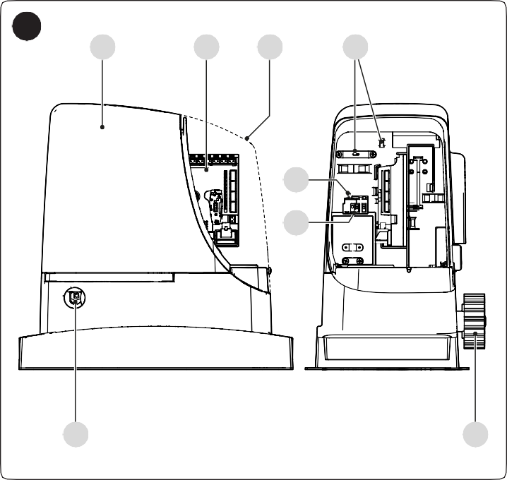
1
G
B
A
H
C
D
E
F
- Top cover
- Electronic control and command unit
- Fuse
- Power supply connector
- Lock for the unlocking key
- Pinion
- Side cover
- Cable pass-through rings

3
INSTALLATION

PRE-INSTALLATION CHECKS

a The installation must be carried out by qualified personnel in compliance with the current legislation, standards and regulations, and with the instructions
provided in this manual.
Before proceeding with the product’s installation, it is necessary to:
- check the integrity of the supply
- check that all the materials are in good working order and suited to the intended use
- make sure that the structure of the gate is suitable for being automated
- make sure that the weight and dimensions of the gate leaf fall within the operating limits specified in the “Product usage limits” paragraph
- check that the force required to start moving the gate leaf is less than half the “maximum torque”, and that the force required to keep the gate leaf moving is less than half the “nominal torque”; compare the resulting values with those specified in the “TECHNICAL SPECIFICATIONS” chapter. The manufacturer recommends a 50% margin on the force, as unfavourable climatic conditions may cause increased friction.
- verify that there are no points of greater friction during the opening and closing movements along the entire gate path
- verify that there is no risk of derailment of the leaf or that it may come off the guides
- verify that the overrun mechanical stops are sturdy enough and that they do not deform even if the leaf should strike them forcefully
- verify that the gate leaf is well balanced: it must not move by itself when left in any position
- make sure that the installation area is not subject to flooding; if necessary, the product must be installed appropriately raised above ground level
- verify that the area where the gearmotor is installed allows for unlocking the latter and manoeuvring easily and safely
- verify that the mounting positions of the various devices are protected against impacts and that the mounting surfaces are sufficiently sturdy
- prevent any parts of the automation from being immersed in water or other liquids
- keep the product away from heat sources and open flames and acid, saline or potentially explosive atmospheres; these may damage the product and cause malfunctions or dangerous situations
- if there is an access door in the gate, or within its range of movement, make sure that it does not obstruct the gate’s normal path; install an appropriate interlock system if necessary
- connect the control unit to an electricity supply line equipped with a safety earthing system
- connect the gate to the earthing device in accordance with the current legislation
- include a device on the electric power line ensuring complete disconnection of the automation from the grid. The disconnection device must have contacts with a sufficient gap to ensure complete disconnection, under the Category III overvoltage conditions, in accordance with the installation instructions. Should it be necessary, this device guarantees fast and safe disconnection from the power supply; it must therefore be positioned in view of the automation. If placed in a non-visible location, it must have a system that blocks any accidental on unauthorised reconnection of the power supply, in order to prevent dangerous situations. The disconnection device is not supplied with the product.

PRODUCT USAGE LIMITS
The data relative to the product’s performances is included in the “TECHNICAL SPECIFICATIONS” chapter and is the only data that allows for properly assessing whether the product is suitable for its intended use.
The structural characteristics of the product make it suitable for use on sliding gates, according to the limits indicated in the following tables.
The actual suitability of the product to automate a specific sliding gate depends on friction and on other factors, even occasional, such as the presence of frost, which may interfere with the gate leaf’s movement.
For an effective check, it is essential to measure the force necessary to move the gate leaf along its entire path and ensure that this is less than half of the “nominal torque” indicated in “TECHNICAL SPECIFICATIONS” chapter (a 50% margin on the force is recommended, as unfavourable climatic conditions may cause increased friction); furthermore, it is necessary to take into account that shown in the following tables to define the number of cycles/hour, the consecutive cycles and maximum speed allowed.

Table 1

RUN1500 - LIMITS IN RELATION TO THE GATE LEAF LENGTH
Gate leaf length (m) | Maximum no. of cycles/hour | Maximum no. of consecutive cycles
Up to 4 | 60 | 30
4 ÷ 6 | 40 | 20
6 ÷ 7 | 34 | 17
7 ÷ 8 | 30 | 15
8 ÷ 10 | 20 | 12
10 ÷ 12 | 20 | 10
12 ÷ 14 | 17 | 8

Table 2

RUN1500 - LIMITS IN RELATION TO THE GATE LEAF WEIGHT
Gate leaf weight (kg) | Percentage of cycles | Maximum speed allowed
Up to 200 | 100% | V6 = Extremely fast
200 ÷ 400 | 100% | V6 = Extremely fast
400 ÷ 500 | 95% | V6 = Extremely fast
500 ÷ 600 | 90% | V5 = Very fast
600 ÷ 700 | 85% | V5 = Very fast
700 ÷ 800 | 80% | V5 = Very fast
800 ÷ 900 | 75% | V5 = Very fast
900 ÷ 1000 | 70% | V4
1000 ÷ 1200 | 65% | V4
1200 ÷ 1350 | 60% | V3
1350 ÷ 1500 | 55% | V3
The length of the leaf allows to determine both the maximum number of cycles per hour and consecutive cycles, while the weight allows to determine the reduction percentage of the cycles and the maximum speed allowed. For example, if the leaf is 5 m long it will be possible to have 40 cycles/hour and
20 consecutive cycles. However, if the leaf weighs 650 kg, they must be reduced to 85%, resulting in 34 cycles/hour and 17 consecutive cycles, while the maximum allowed speed is V5: “Very fast”. To prevent overheating, the control unit has a manoeuvre limiter that works based on the motor force and duration of the cycles, intervening whenever the maximum limit is exceeded. The manoeuvre limiter also measures the ambient temperature and further reduces the number of manoeuvres in case of particularly high temperatures.

Product durability
The product’s durability is its average economic life value and is strongly influenced by the degree of severity of the manoeuvres: in other words, the sum of all factors that contribute to product wear.
To estimate the durability of your automated device, proceed as follows:
Durability in cycles (No.)
- add the values of the items in “Table 3” relative to the system’s conditions
- in the graph shown in “Figure 2”, from the value obtained above, trace a vertical line until it intersects the curve; then, trace a horizontal line until it intersects the line of the “manoeuvre cycles”. The value obtained is the estimated lifetime of your product.
The durability values shown in the graph can only be obtained if the maintenance schedule is strictly observed – see the “ PRODUCT MAINTENANCE” chapter. The durability is estimated on the basis of the design calculations and the results of tests effected on prototypes. Being an estimate, therefore, it offers no explicit guarantee of the product’s actual useful life.
Example of durability calculation: automation of a gate with a 6.5 m-long leaf weighing 450 kg, installed near the sea “Table 3” shows the “severity indices” for this type of installation: 10% (“Leaf length”), 20% (“Leaf weight”) and 15% (“Presence of dust, sand or salt”).
These indicators must be added together to obtain the overall severity index, which in this case is 45%. With the value identified (45%), look at the horizontal axis of the graph (“severity index”) and identify the value corresponding to the number of “manoeuvre cycles” that the product can perform throughout its lifetime – roughly 200,000 cycles.

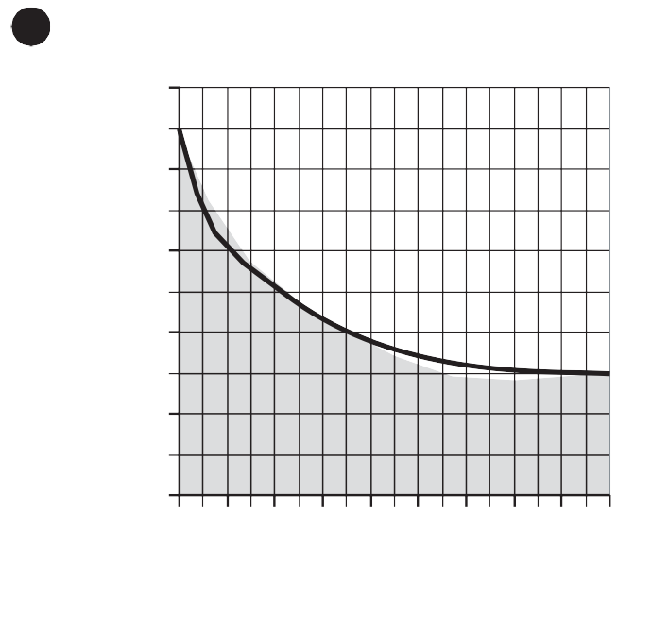
PRODUCT IDENTIFICATION AND OVERALL DIMENSIONS
2

500.000
450.000
400.000
350.000
300.000
250.000
200.000
150.000
100.000
50.000
0
10 20 30 40 50 60 70 80 90 100
Severity index (%)
The overall dimensions and the label (A), which allows for identifying the product, are shown in “Figure 3”.

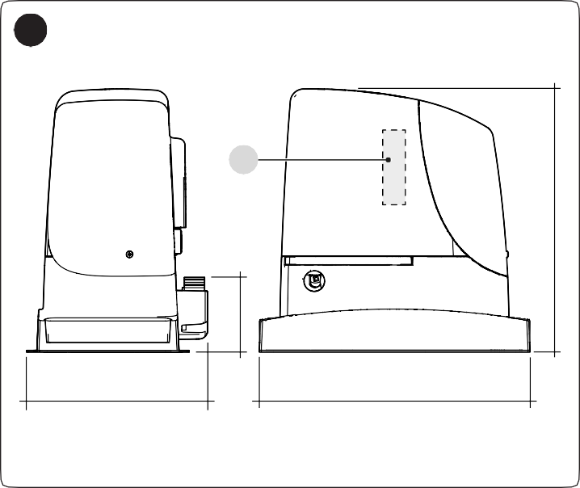
Table 3
3
A
255
400
108
390
PRODUCT DURABILITY
 |  | Severity index
Leaf length | < 6m | 5%
Leaf length | 6÷9m | 10%
Leaf length | 9÷12m | 15%
Leaf length | 12÷14m | 20%
Leaf weight | 100÷200kg | 5%
Leaf weight | 200÷400kg | 10%
Leaf weight | 400÷600kg | 20%
Leaf weight | 600÷800kg | 30%
Leaf weight | 800÷1000kg | 40%
Leaf weight | 1000÷1200kg | 50%
Leaf weight | 1200÷1500kg | 60%
Ambient temperature greater than 40°C or below 0°C, or humidity greater than 80% |  | 20%
Presence of dust, sand or salinity |  | 15%
Motor speed setting greater than “L4 fast” |  | 15%

PRE-INSTALLATION WORKS
The figure shows an example of an automation system, constructed using Nice components.
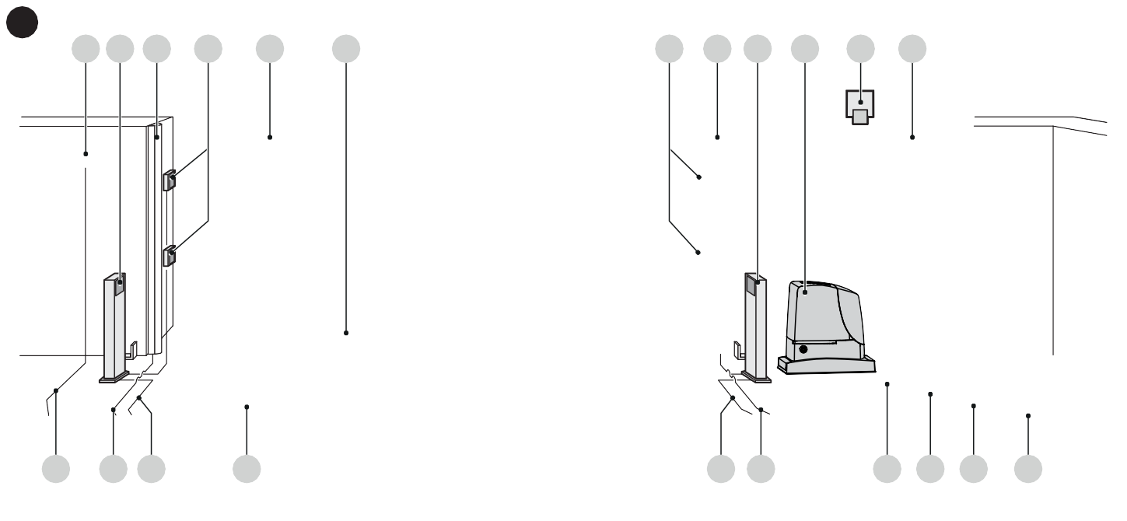
1
4 3 2
6 5
4
5 6
7
I J
C G B H
F
E
A B C D
4

- Key selector
- Photocells on column
- Main fixed edge (optional)
- Photocells
- Main movable edge
- Rack
- Secondary fixed edge (optional)

RUN1500
- Warning light with incorporated antenna
- Secondary movable edge (optional)
These above-mentioned components are positioned according to a typical standard layout. Using the layout in “Figure 4” as a reference, define the approximate position in which each component of the system will be installed.

Table 4
TECHNICAL SPECIFICATIONS OF ELECTRICAL CABLES
Identification no. | Cable characteristics
1 | GEARMOTOR POWER SUPPLY cable  1 cable 3 x 1.5 mm²  Maximum length 30 m [note 1]
2 | WARNING LIGHT cable  1 cable 2 x 0.5 mm² Maximum length 20 m
3 | ANTENNA cable  1 x RG58-type shielded cable  Maximum length 20 m; recommended < 5 m
4 | MOVABLE EDGES cable  1 cable 2 x 0.5 mm² [note 4]  Maximum length 30 m [note 5]
5 | FIXED EDGES cable  1 cable 2 x 0.5 mm² [note 4] Maximum length 30 m
6 | PHOTOCELL cable 1 cable 2 x 0.5 mm²  Maximum length 30 m [note 2]
7 | KEY SELECTOR cable  2 cables 2 x 0.5 mm² [note 3] Maximum length 50 m

Note 1 If the power supply cable is longer than 30 m, a cable with larger cross-sectional area (3 x 2.5 mm²) must be used and a safety earthing system must be installed near the automation.
Note 2 If the BlueBus cable is longer then 30 m, up to maximum 50 m, it is necessary to use a cable with a greater cross- sectional area (2 x 1 mm²).
Note 3 These two cables can be replaced by a single 4 x 0.5 mm² cable.
Note 4 If more than one edge is present, refer to the “ STOP input” paragraph for the type of connection recommended.
Note 5 Movable edges must be connected to sliding leaves using special devices, which enable the connection even when the leaf is moving.

a Before proceeding with the installation, prepare the required electrical cables by referring to “Figure 4” and to the indications specified in the “TECHNICAL
SPECIFICATIONS” chapter.

a The cables used must be suited to the type of environment of the installation site.

a When laying the pipes for routing the electrical cables, take into account that any water deposits in the junction boxes may cause the connection pipes
to form condensate inside the control unit, thus damaging the electronic circuits.

INSTALLING THE GEARMOTOR

a Incorrect installation may cause serious physical injury to the person working on the system or to its future users.
Before starting to assemble the automation, complete the preliminary checks described in the “ Pre-installation checks” and “Product usage limits” paragraphs.

m Before proceeding with installation, it is advisable to position the door halfway along its path and then anchor the gearmotor to the foundation plate. This
ensures that the mechanical limit switches can self- adjust.
If the supporting surface already exists, the gearmotor must be mounted directly onto the surface using appropriate fasteners, for example expansion bolts.
Alternatively, to mount the gearmotor:
- dig a suitably sized foundation using the indicated measurements as a reference

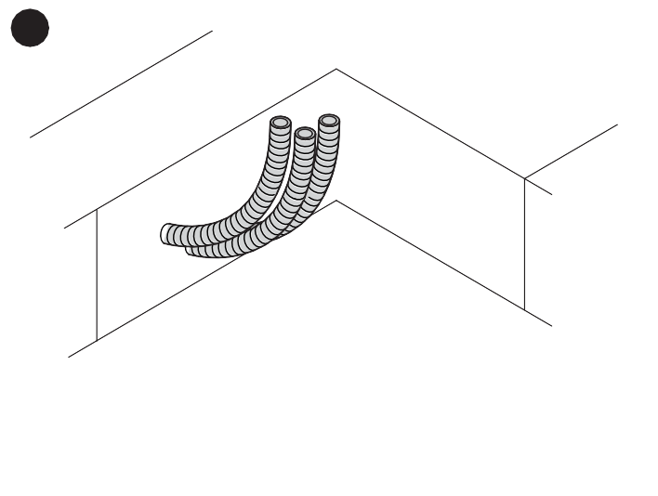
6
- assemble the four anchoring devices (A) onto the foundation plate, placing one nut under and one over the plate; the nut beneath the plate must be tightened so that the threaded part protrudes by roughly 30÷40 mm above the plate
0 ÷ 10


7
30÷40 mm

A

- pour the concrete and, before it starts to set, place the foundation plate (B) at the levels indicated previously; make sure that it lies parallel to the gate and perfectly level
5
400
0 ÷ 50
0 ÷ 50
400
240
- wait for the concrete to set fully
- remove the two nuts above the plate (C)
240
0 ÷ 10

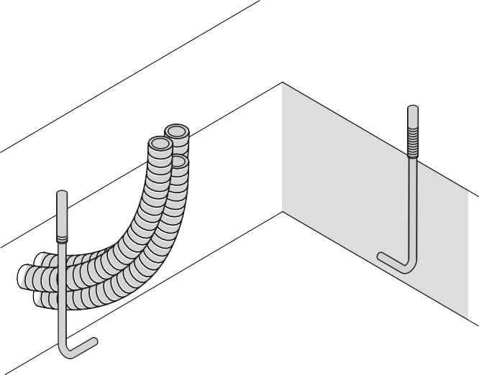
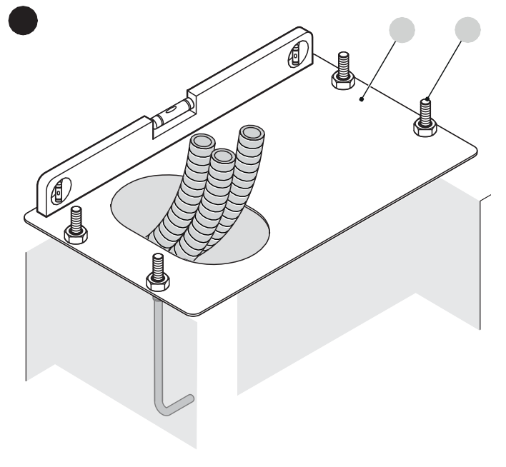
- arrange one or two pipes for routing the electrical cables
8
B
C

- place the gearmotor (D) on the plate
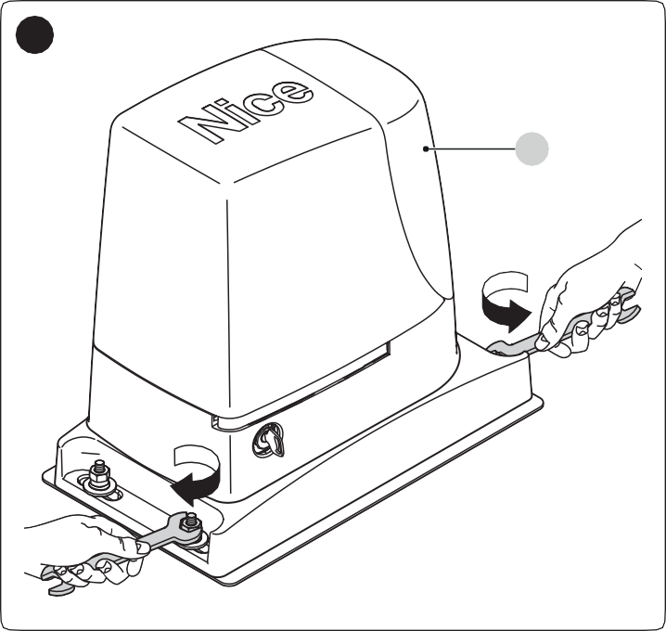
- make sure that the gearmotor lies perfectly parallel with the leaf and then slightly tighten the four nuts and washers provided
9
D
- check that the clearance between the rack and pinion is around 1–2 mm along the entire length
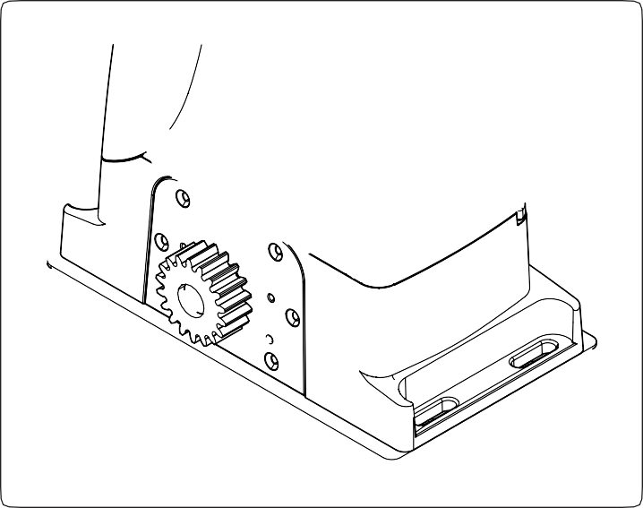
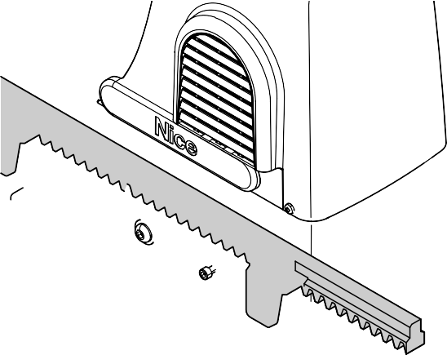
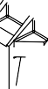

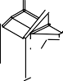
- fasten the rack to the gate leaf with adequate fasteners
11
1÷2 mm

- at this point, if the rack is already present, vigorously tighten the gearmotor’s fixing nuts, cover the fixing nuts with the relevant caps (“Figure 12”) and adjust the mechanical limit switches as described in the “Adjusting the mechanical limit switches” paragraph
If the rack must to be installed, proceed as follows:
- unlock the gearmotor as indicated in the “Manually unlocking and locking the gearmotor” paragraph
- manually position the door at least 50 cm away from the limit switch stop (during the closing phase)
- place the rack on the pinion then verify that the start of the rack matches the start of the gate leaf
- slide the gate and always use the pinion as a reference to fasten the other elements of the rack
- cut off the excess section of rack
- try opening and closing the gate leaf several times and check that the rack slides aligned on the pinion with a maximum misalignment of 5 mm
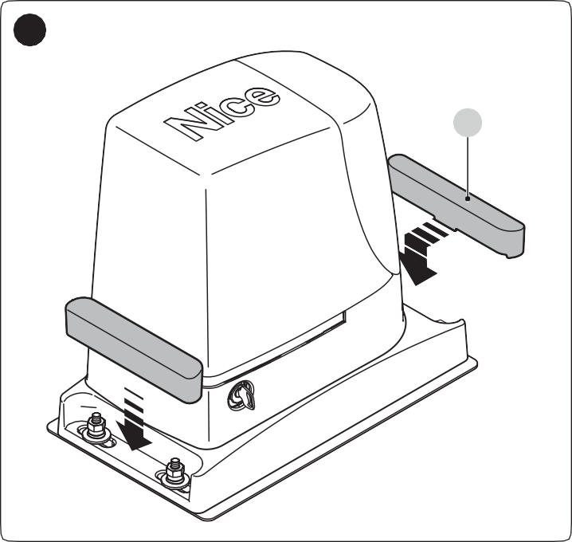
- vigorously tighten the fixing nuts of the gearmotor, making sure that it is firmly anchored to the ground; cover the nuts with the relevant caps (E).
12
E

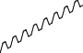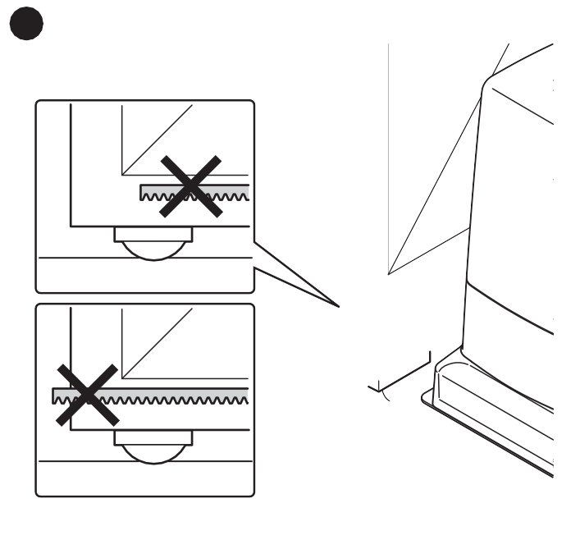
10

ADJUSTING THE MECHANICAL LIMIT SWITCHES
To adjust the limit switches, proceed as follows:
- unlock the gearmotor with the relevant key provided (refer to the “Manually unlocking and locking the gearmotor” paragraph)
- manually perform a complete opening and closing manoeuvre to allow the mechanical limit switches to self- adjust.

m During this manoeuvre, check that the rack moves aligned with the pinion, with a maximum misalignment of 5 mm, and that there is a 1–2 mm
clearance between pinion and rack along its entire length.

4
ELECTRICAL CONNECTIONS

  - PRELIMINARY CHECKS

f All electrical connections must be made with the system disconnected from the mains electricity and with the back-up battery (if present) disconnected.

a The connection operations must only be carried out by qualified personnel.
To make the electrical connections:
- insert all the connecting cables into the various devices, leaving them 20–30 cm longer than necessary. Refer to “ Table 4” for the type of cables and to “Figure 4” for the connections.
- use a clamp to hold together all the cables entering the gearmotor then place the clamp slightly below the cable entry hole
- connect the power cable (A) to the relevant terminal as shown in the figure, then use another clamp to fasten the cable onto the first cable ring

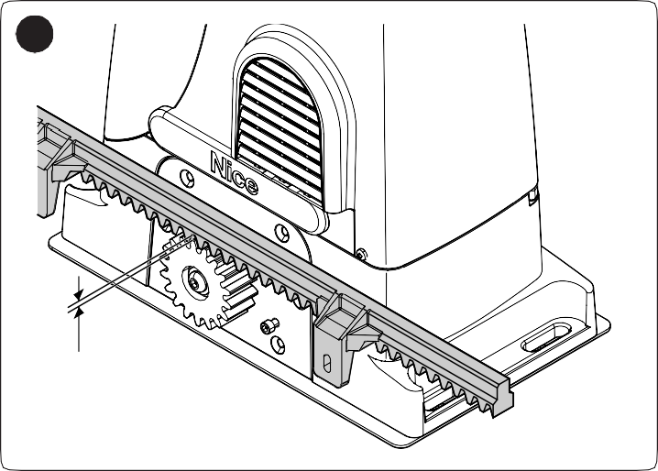
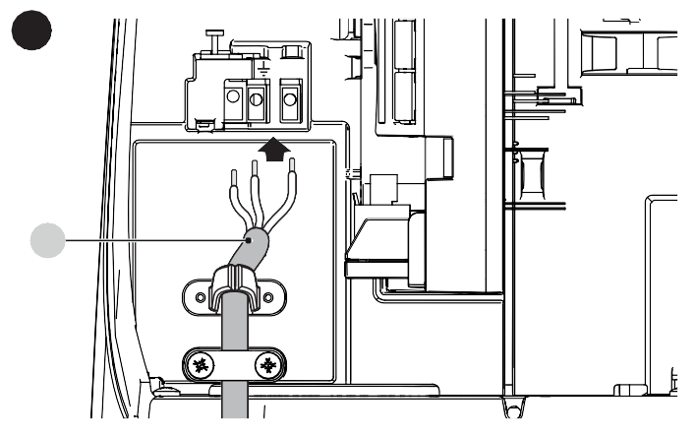
- lastly, manually position the leaf halfway along its path and lock the gearmotor using the relevant key (refer to the “Manually unlocking and locking the gearmotor” paragraph).
13
1÷2 mm
15

A

MANUALLY UNLOCKING AND LOCKING THE GEARMOTOR
The gearmotor is equipped with a mechanical unlocking device that can be used to open and close the gate manually.
These manual operations should only be performed in case of a power outage, malfunctions or during the installation phases. To unlock the device:
- insert the key (A) and turn it clockwise by 90°

- connect the other cables according to the diagram shown in “Figures 16” and 17 For greater convenience, the terminals are removable.
- after making the connections, lock the cables in the appropriate rings. The excess part of the antenna cable must be secured to the other cables.

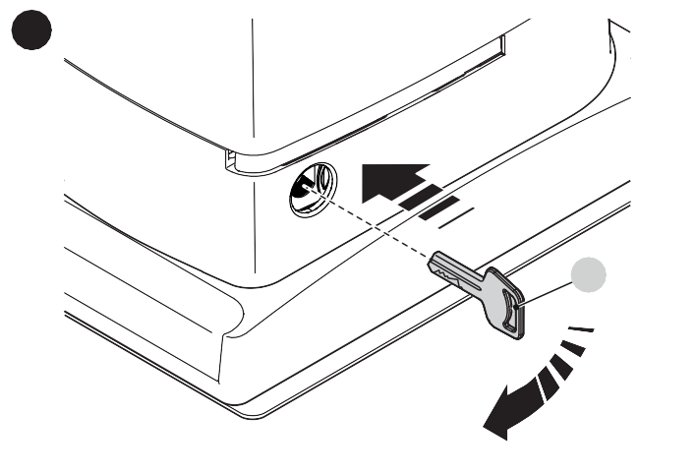
14

A
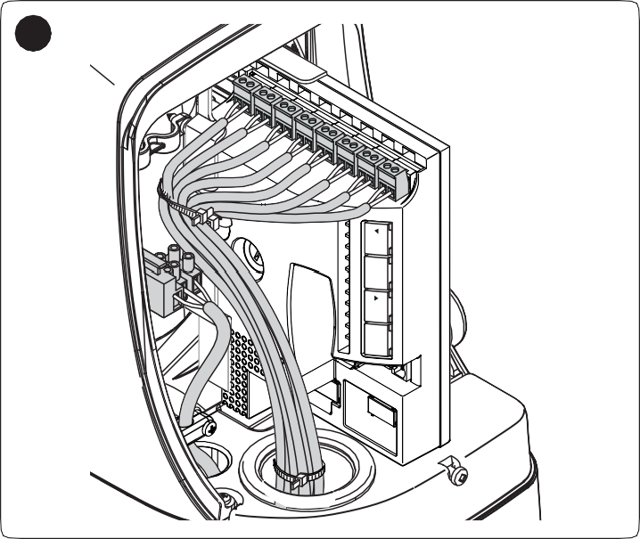
- the gate leaf can now be moved manually to the desired position.
16
L8 L7 L6 L5 L4 L3 L2 L1
Close Stop/Set Open

To lock the device:
- turn the key (A) anti-clockwise by 90°
- remove the key.

l To connect 2 motors on opposite leaves, refer to the “Gearmotor in SLAVE mode” paragraph.

WIRING DIAGRAM AND DESCRIPTION OF CONNECTIONS
Flash
OGI
Bluebus
Stop
Sbs
Open
Receiver
Close
L8 L7 L6 L5 L4 L3 L2 L1
Aux In
Close
Stop/Set Open

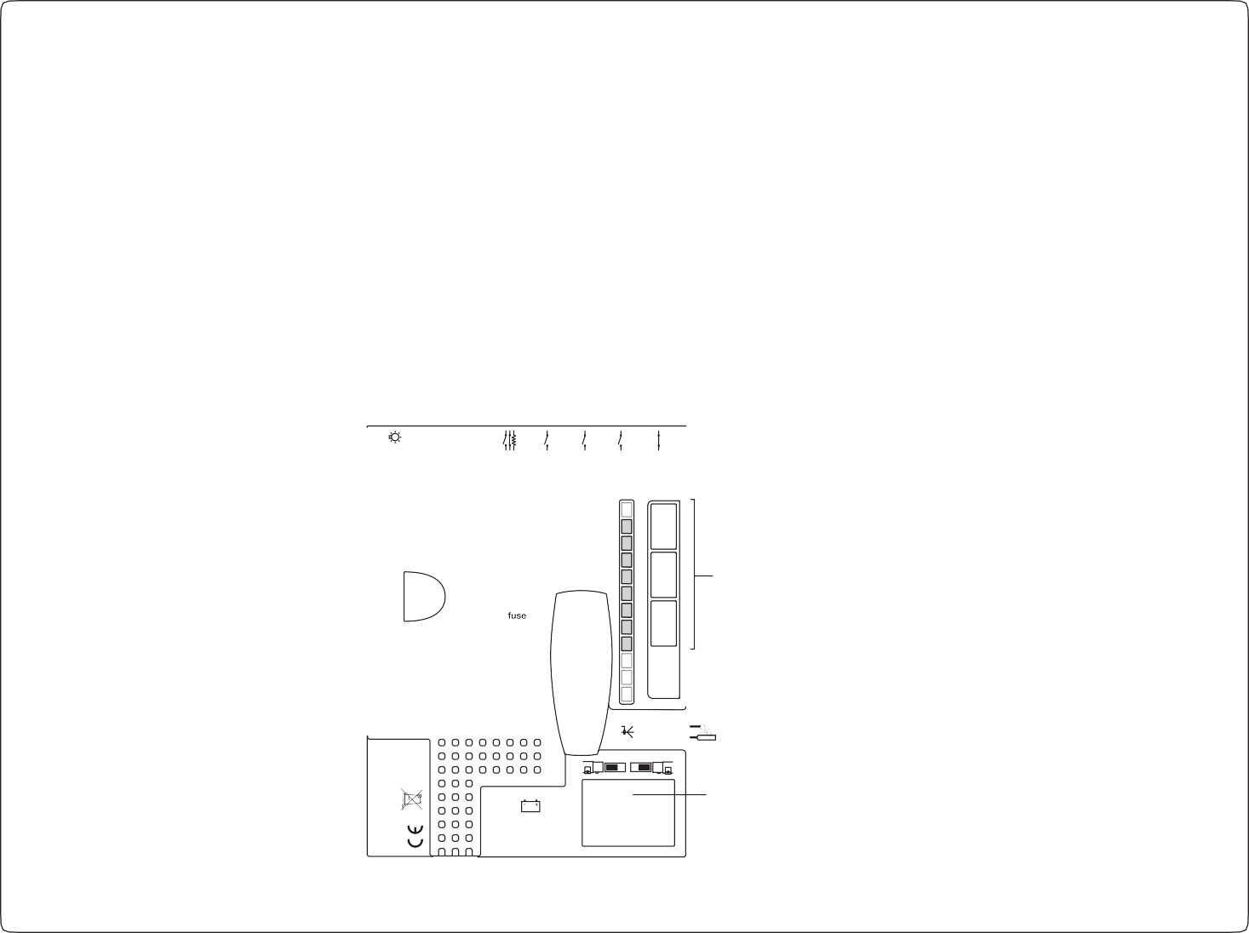




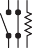
Wiring diagram
17
FLASH
OGI 24V 4W
TX
RX
STOP
SBS
Bluebus
Bluebus
NO NC 8K2
NO
NC
NO
NO
AUX IN CLOSE OPEN
LED
KEYS
1.6AT
SELECTOR
IBT4N

Description of connections
Aerial

Table 5
ELECTRICAL CONNECTIONS
Terminals | Description
FLASH | Output for one or two Nice or similar type warning lights with 12 V bulb only, maximum 21 W.
OGI | “Open Gate Indicator” output; a 24 V (max 4 W) signalling light can be connected.  It can also be programmed for other functions; see the “Level 2 programming (adjustable parameters)” paragraph.
BLUEBUS | This terminal can be used to connect compatible devices, which are all connected in parallel with only two wires carrying both the electric power and communication signals.  For further information on the BlueBUS, refer to the “BlueBUS” paragraph.
STOP  NO-NC-8K2 | Input for devices that suspend or even stop the current manoeuvre; “Normally Closed” and “Normally Open” contacts or fixed resistor devices can be connected by suitably configuring the input.  For further information on the STOP function, refer to the “STOP input” paragraph.
Sbs | Input for devices that control the movement in Step-by-Step mode; it is possible to connect “Normally Open” contacts.
OPEN | Input for devices that control the opening movement only; it is possible to connect “Normally Open” contacts.
CLOSE | Input for devices that control the closing movement only; it is possible to connect “Normally Open” contacts.
AUX_IN  (Auxiliary Input) | Input for devices that suspend or stop the current manoeuvre; “Normally Closed” contacts can be connected to this input.  The Oview accessory can be used to modify the input’s functions; the input is factory-configured as a STOP input.
ANTENNA | Antenna connection input for radio receiver; the antenna is incorporated in the warning light; alternatively, an external antenna can be used.

5
FINAL CHECKS AND START-UP
It is advisable to position the leaf approximately halfway along its path before starting the automation check and start-up phases, so that the leaf is free to open and close.

CHOOSING THE DIRECTION
Choose the direction of the opening manoeuvre on the basis of the gearmotor’s position in relation to the gate leaf. If the leaf must move towards the left to open, shift the selector towards the left as shown in “Figure 18”.
Flash
OGI
L2 L1
Open
- once this phase terminates, the “Stop” LED must be lit and LEDs “L1” and “L2” must switch off (LEDs “L3” and “L4” could start flashing).

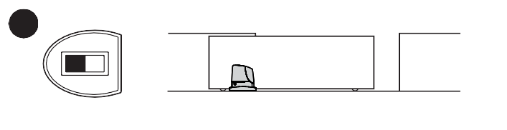
18

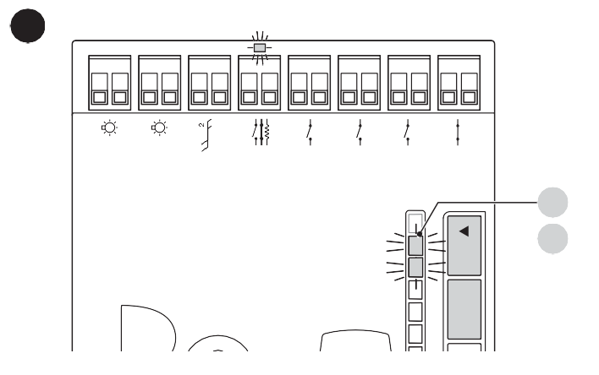
If the leaf must move towards the right to open, the selector must be shifted towards the right as shown in “Figure 19”.
20

L1 L2
Bluebus
Stop
Sbs
Open
Close
L5 L4 L3
Aux In
Stop/Set

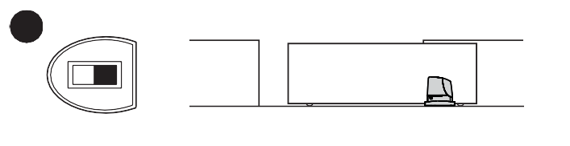
19

POWER SUPPLY CONNECTION

a The power supply connections must only be made by qualified and experienced personnel possessing the necessary requirements and in full conformity
to the laws, regulations and standards in force.
As soon as the product is powered, a few simple checks should be carried out:
- check that the BlueBus LED flashes regularly with one flash per second.
- make sure that the LEDs on the photocells (both the TX and RX) also flash; the type of flashing is irrelevant, since it depends on other factors.
- make sure that the warning light connected to the FLASH output and the indicator light connected to the OGI output are off.
If the above conditions are not satisfied, immediately switch off the power supply to the control unit and carefully check the electrical connections.
Further useful information on searching and diagnosing faults is included in the “Troubleshooting” paragraph.

DEVICE LEARNING
Once the power supply has been connected, the control unit must recognise the devices connected to the “BlueBUS” and “STOP” inputs. Prior to this phase, LEDs “L1” and “L2” will flash to signal that the device learning procedure must be performed. m The learning phase must be carried out even if no
device is connected to the control unit.
To do this:
- simultaneously press and hold the f and
g buttons
- release the buttons when LEDs “L1” and “L2” start
flashing quickly (after roughly 3 seconds)
- wait a few seconds until the control unit has completed the device learning phase
The learning process of connected devices can be repeated
at any time, even after the installation (for example, whenever a device must be added); to complete the new learning process, refer to the “Learning of other devices” paragraph.

LEAF LENGTH LEARNING
Once the devices have been learned, LEDs “L3” and “L4”; will start flashing; this means that the control unit must recognise the length of the gate leaf (distance between the closing and opening limit switches); this measurement is necessary to calculate the deceleration points and the partial opening point. To do this:
- simultaneously press and hold the h and
g buttons
- release the buttons when the manoeuvre starts (after
roughly 3 seconds)
- check that the current manoeuvre is an opening manoeuvre. If not, press the g button and carefully check the “Choosing the direction” paragraph then repeat the process from point 1
- wait for the control unit to complete the opening manoeuvre until the gate reaches the opening limit switch; the closing manoeuvre will start immediately afterwards
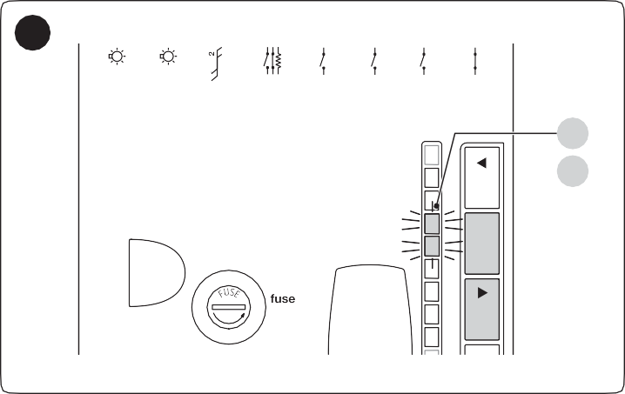
- wait for the control unit to fully close the gate.
21
L3
L4
1.6AT
Flash
OGI
Bluebus
Stop
Sbs
Open
Close
L8 L7 L6 L5 L4 L3 L2 L1
Aux In
Stop/Set Open

If the above conditions are not satisfied, immediately switch off the power supply to the control unit and carefully check the electrical connections.
Close
Further useful information on searching and diagnosing faults is included in the “Troubleshooting” paragraph.

CHECKING THE GATE MOVEMENT
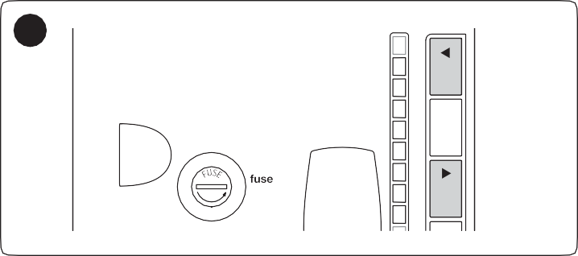
Once the leaf length has been learned, it is advisable to carry out a few manoeuvres in order to verify that the gate moves properly.
22
1.6AT
L8 L7 L6 L5 L4 L3 L2 L1
Stop/Set Open

To do this:
Close
- press the f button to open the gate; check that the gate opens regularly without any variations in speed; the leaf must only slow down when it is between 70 cm and 50 cm from the opening limit switch and then stop at 2–3 cm from the opening mechanical stop when the limit switch triggers
- press the h button to close the gate; check that the gate closes regularly without any variations in speed; the leaf must only slow down when it is between 70 cm and 50 cm from the closing limit switch and then stop at 2–3 cm from the closing mechanical stop when the limit switch triggers
- during the manoeuvre, check that the warning light flashes with 0.5 s on/0.5 s off intervals. If present, also check that the indicator connected to the OGI terminal flashes: slow during the opening movement, fast during the closing movement
- open and close the gate several times to make sure that there are no points of excessive friction and that there are no defects in the assembly or adjustments
- check that the gearmotor, rack and limit switch brackets are solid, stable and suitably resistant even during sudden gate acceleration or slowdown movements.

CONNECTING OTHER DEVICES
If the user needs to power external devices, such as a proximity reader for transponder cards or the light of the key selector switch, power can be tapped as shown in the figure.
The power supply voltage is 24Vc -30% ÷ +50% with a maximum available current of 100mA.
23
STOP SBS
(-) (+)

6
TESTING AND COMMISSIONING
These are the most important phases of the automation’s construction, as they ensure maximum safety of the system. The test can also be used to periodically verify the devices making up the automation.

m Testing and commissioning of the automation must be performed by skilled and qualified personnel, who are responsible for the tests required to
verify the solutions adopted according to the risks present, and for ensuring that all legal provisions, standards and regulations are met, in particular all the requirements of the EN 12445 standard, which defines the test methods for checking gate automations.
The additional devices must undergo specific testing, both in terms of their functions and their proper interaction with the control unit. Refer to the instruction manuals of the individual devices.

TESTING
To run the test:
- verify that all the instructions stated in the “GENERAL SAFETY WARNINGS AND PRECAUTIONS” chapter
have been strictly observed
- unlock the gearmotor as indicated in the “Manually unlocking and locking the gearmotor” paragraph
- make sure that the leaf can be moved manually during both the opening and closing phases with a force not exceeding 390N (roughly 40 kg)
- lock the gearmotor
- using the control devices (transmitter, control button, key selector, etc.), test the gate’s opening, closing and stoppage movements to make sure that the leaves move as intended. Several tests should be carried out to assess the movement of the leaves and detect any defects in the installation and adjustment, besides any points of excessive friction
- check, one-by-one, that all safety devices mounted on the system (photocells, sensitive edges, etc.) work properly. Each time a device intervenes, the “Bluebus” LED on the control unit will emit two faster flashes to confirm the recognition
- if potentially dangerous situations due to the movement of the leaves have been prevented by limiting the impact force, the latter must be measured according to the EN 12445 standard and, if the “motor force” control is used to aid the system in reducing the impact force, it is necessary to test various adjustments to find the one that gives the best results.

COMMISSIONING

a Commissioning can only be performed after all testing phases have been successfully completed.

a Before commissioning the automation, ensure that the owner is properly informed of all residual risks and hazards.

a The gate cannot be commissioned partially or under “temporary” conditions.

To commission the automation:
- compile the automation’s technical file, which must include the following documents: overall drawing of the automation, wiring diagram, risk assessment and relative solutions adopted, the manufacturer’s declaration of conformity for all devices used and the declaration of conformity compiled by the installer
- affix a permanent label or sign near the gate specifying the operations for unlocking the gate and manoeuvring it manually “Figure 24“
L8 L7 L6 L5 L4 L3 L2 L1
Stop/Set
Open

7
PROGRAMMING
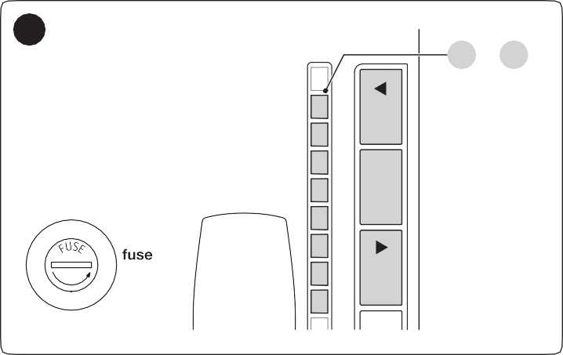
The following 3 buttons are located on the control unit: f, g and h (“Figure 25”) which can be used both for commanding the control unit during the testing phase and to programme the available functions.
25
L1 ... L8
1.6AT

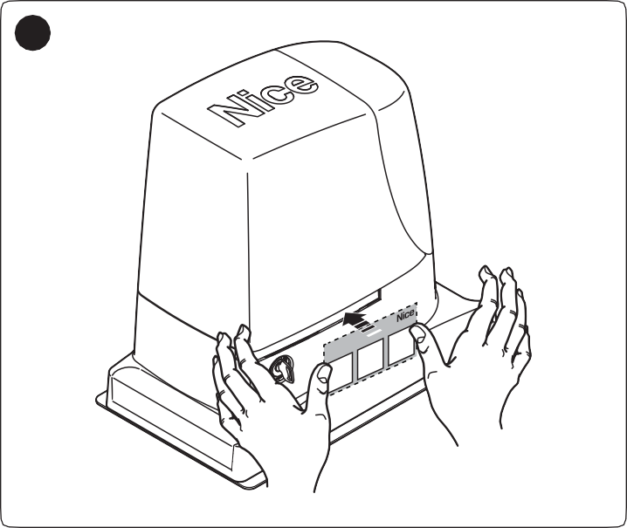
The available programmable functions are grouped into two levels and their operating status is signalled by eight LEDs “L1
24
r
Close
PerSblocca re - Pour dérbayer- To unblock
Umzu entriegeln - Para desbloquear
Odblokowanie - Omte deblokke ren- Отпереть
1
2
3
... L8” located on the control unit (LED lit = function enabled; LED off = function disabled).

- affix a data plate on the gate specifying at least the following data: type of automation, name and address of the manufacturer (responsible for commissioning), serial number, year of manufacture and CE mark
- compile the declaration of conformity of the automation and hand it to the owner of the automation
- compile the User Manual of the automation and hand it to the owner of the automation
- compile and provide the owner with the automation’s “Maintenance schedule”, containing the maintenance instructions for all the automation’s devices.

l For all the above-mentioned documentation, Nice – through its technical assistance service – provides the following: pre-completed forms.

USING THE PROGRAMMING BUTTONS
- Button for commanding the gate opening Selection button during the programming phase.
- Button used to stop a manoeuvre
If pressed for more than 5 seconds, it allows for entering
the programming mode.

- Button for commanding the gate’s closure Selection button during the programming phase.

LEVEL 1 PROGRAMMING (ON-OFF)
All the Level 1 functions are factory-set to “OFF” and can be modified at any time. To check the various functions, refer to “Table 6”.

Level 1 programming procedure

m The user has maximum 10 seconds to press the buttons consecutively during the programming procedure, after which time the procedure terminates automatically and memorises the changes made up to then.
To perform Level 1 programming:
- press and hold the g button until LED “L1” starts flashing
- release the g button when LED “L1” starts flashing
- press the f or h button to move the flashing LED to the LED associated with the function to be modified
- press the g button to change the status of the function:
  - short flash = OFF
  - long flash = ON
- wait 10 seconds (maximum time) to exit the programming mode.

l To set other functions to “ON” or “OFF”, while the procedure is running, repeat points 2 and 3 during the phase itself.

Table 6
LEVEL 1 FUNCTIONS (ON-OFF)
LED | Function | Description
L1 | Automatic closing | Function ENABLED: after an opening manoeuvre there is a pause (equal to the set pause time), after which the control unit automatically starts a closing manoeuvre. The pause time is set by default to 30 seconds.  Function NOT ENABLED: the system works in “semi-automatic” mode.
L2 | Close after photo | Function ENABLED: the behaviour changes depending on whether the “Automatic Closing” function is enabled or not.  With “Automatic Closing” disabled: the gate will always reach the fully open position (even if the photocell disengages before). The disengaging of the photocell triggers the automatic re-closing after a 5-second pause.  When “Automatic Closing” is enabled: the opening manoeuvre stops immediately after the photocells have disengaged. After 5 seconds, the gate will start closing automatically.  The “Close After Photo” function is always disabled in manoeuvres interrupted by a Stop command. Function DISABLED: the pause time is that which has been programmed or automatic re-closing will not take place if the function is disabled.
L3 | Always Close | Function ENABLED: in the event of a blackout, even of short duration, if the control unit detects that the gate is open when the electricity is restored, it automatically starts a closing manoeuvre preceded by a 5-second pre-flash.  Function DISABLED: when the electricity is restored, the gate remains in the same position.
L4 | Stand-by | Function ENABLED: 1 minute after the completion of the manoeuvre, the control unit switches off the BlueBUS output (and, therefore, the devices) and all LEDs, with the exception of the BlueBUS LED, which flashes more slowly. When the control unit receives a command, it restores full operation.  Function DISABLED: there will be no reduction in consumption.  This function is useful, in particular, during operation with the back-up battery.
L5 | Peak | Function ENABLED: the gradual acceleration at the beginning of each manoeuvre will be disengaged; it allows for having peak thrust and is useful whenever static friction is high, e.g. if snow or ice are blocking the gate.  Function DISABLED: the manoeuvre will start with a gradual acceleration.
L6 | Pre-flashing | Function ENABLED: a 3-second pause can be added between the switching on of the warning light and the start of the manoeuvre, to warn the user in advance of a potentially dangerous situation.  Function DISABLED: the signalling of the warning light coincides with the start of the manoeuvre.
L7 | “Close” becomes “Partial Open” | Function ENABLED: the “Close” input of the control unit switches its operation to “Partial Open”.
L8 | “Slave” mode | Function ENABLED: it is possible to synchronise the functioning of 2 motors on opposite leaves where one motor functions as master and the other as slave; for further information, refer to the “Gearmotor in SLAVE mode” paragraph.

l During normal operation, LEDs “L1 ... L8” are on/off depending on the status of the respective function; for example, “L1” is lit when the “Automatic Closing” function is enabled.

LEVEL 2 PROGRAMMING (ADJUSTABLE PARAMETERS)
All Level 2 parameters are factory-set as highlighted in “GREY” in “Table 7” and can be modified at any time. The parameters can be adjusted to between 1 and 8. To verify the value corresponding to each LED, refer to “Table 7”.

Level 2 programming procedure

m The user has maximum 10 seconds to press the buttons consecutively during the programming procedure, after which time the procedure terminates automatically and memorises the changes made up to then.
To perform Level 2 programming:
- press and hold the g button until LED “L1” starts flashing
- release the g button when LED “L1” starts flashing
- press the f or h button to move the flashing LED to the “entry LED” associated with the parameter to be modified
- press and hold the g button. With the g button pressed:
  - wait roughly 3 seconds, until the LED representing the current level of the parameter to be modified lights up
  - press the f or h button to shift the LED associated with the parameter’s value
- release the g button
- wait 10 seconds (maximum time) to exit the programming mode.

l To set multiple parameters during the procedure's execution, repeat the operations from point 2 to point 4 during the phase itself.
l The set value highlighted in grey (“Table 7”) indicates that this value is the factory setting.

Table 7
LEVEL 2 FUNCTIONS (ADJUSTABLE PARAMETERS)
Entry LED | Parameter | LED  (level) | Set value | Description
L1 | Pause Time | L1 | 5 seconds | Adjusts the pause time, in other words, the time before automatic re-closure. It is only effective if the “Automatic Closing” function is enabled.
L1 | Pause Time | L2 | 15 seconds
L1 | Pause Time | L3 | 30 seconds
L1 | Pause Time | L4 | 45 seconds
L1 | Pause Time | L5 | 60 seconds
L1 | Pause Time | L6 | 80 seconds
L1 | Pause Time | L7 | 120 seconds
L1 | Pause Time | L8 | 180 seconds
L2 | Step-by-Step function | L1 | Open - Stop - Close - Stop | Controls the sequence of controls associated with the Sbs input or the 1st radio command.
L2 | Step-by-Step function | L2 | Open - Stop - Close - Open
L2 | Step-by-Step function | L3 | Open - Close - Open - Close
L2 | Step-by-Step function | L4 | Condominium
L2 | Step-by-Step function | L5 | Condominium 2 (more than 2 sec triggers “Stop”)
L2 | Step-by-Step function | L6 | Step-by-Step 2 (less than 2 sec triggers “Partial Open”)
L2 | Step-by-Step function | L7 | Hold-to-run
L2 | Step-by-Step function | L8 | Opening in “semi-automatic” mode, closing in “hold-to-run” mode
L3 | Motor speed | L1 | Very slow | Adjusts the motor speed during normal manoeuvres.
L3 | Motor speed | L2 | Slow | Adjusts the motor speed during normal manoeuvres.
L3 | Motor speed | L3 | Medium | Adjusts the motor speed during normal manoeuvres.
L3 | Motor speed | L4 | Fast | Adjusts the motor speed during normal manoeuvres.
L3 | Motor speed | L5 | Very fast | Adjusts the motor speed during normal manoeuvres.
L3 | Motor speed | L6 | Extremely fast | Adjusts the motor speed during normal manoeuvres.
L3 | Motor speed | L7 | Opens “Fast”; closes “Slow” | Adjusts the motor speed during normal manoeuvres.
L3 | Motor speed | L8 | Opens “Extremely fast”; closes “Fast” | Adjusts the motor speed during normal manoeuvres.

LEVEL 2 FUNCTIONS (ADJUSTABLE PARAMETERS)
Entry LED | Parameter | LED (level) | Set value | Description
L4 | OGI  output | L1 | “Gate Open Indicator” (G.O.I.) function | Adjusts the function associated with the OGI output [regardless of the associated function, the output – when enabled – supplies  a voltage of 24 V (–30 +50%) with 4 W maximum power].
L4 | OGI  output | L2 | Enabled if gate leaf closed
L4 | OGI  output | L3 | Enabled if gate open
L4 | OGI  output | L4 | Enabled with radio output no. 2
L4 | OGI  output | L5 | Enabled with radio output no. 3
L4 | OGI  output | L6 | Active with radio output no. 4
L4 | OGI  output | L7 | Maintenance indicator
L4 | OGI  output | L8 | Electric lock
L5 | Motor force | L1 | Ultra-light gate | Adjusts the motor force control system to adapt it to the gate’s weight. The force control system also measures the ambient temperature and increases the motor force automatically in case of particularly cold temperatures.
L5 | Motor force | L2 | Very light gate
L5 | Motor force | L3 | Light gate
L5 | Motor force | L4 | Average gate
L5 | Motor force | L5 | Medium-heavy gate
L5 | Motor force | L6 | Heavy gate
L5 | Motor force | L7 | Very heavy gate
L5 | Motor force | L8 | Ultra-heavy gate
L6 | Partial Open | L1 | 0,5 mt | Adjusts the degree of partial opening, which can be controlled through radio command no. 2  or with “CLOSE”; if the “Close” function is present, it switches to “Partial Open”
L6 | Partial Open | L2 | 1 mt
L6 | Partial Open | L3 | 1,5 mt
L6 | Partial Open | L4 | 2 mt
L6 | Partial Open | L5 | 2,5 mt
L6 | Partial Open | L6 | 3 mt
L6 | Partial Open | L7 | 3,4 mt
L6 | Partial Open | L8 | 4 mt
L7 | Maintenance notice | L1 | Automatic (depending on the severity of the manoeuvres) | Adjusts the number of manoeuvres after which the automation maintenance request is triggered (see the ““Maintenance notice” function” paragraph).
L7 | Maintenance notice | L2 | 1000
L7 | Maintenance notice | L3 | 2000
L7 | Maintenance notice | L4 | 4000
L7 | Maintenance notice | L5 | 7000
L7 | Maintenance notice | L6 | 10000
L7 | Maintenance notice | L7 | 15000
L7 | Maintenance notice | L8 | 20000
L8 | List of malfunctions | L1 | Result of 1st manoeuvre (most recent) | Allows for checking the type of anomaly that occurred in the last 8 manoeuvres (see the “Anomaly log” paragraph).
L8 | List of malfunctions | L2 | Result of 2nd manoeuvre
L8 | List of malfunctions | L3 | Result of 3rd manoeuvre
L8 | List of malfunctions | L4 | Result of 4th manoeuvre
L8 | List of malfunctions | L5 | Result of 5th manoeuvre
L8 | List of malfunctions | L6 | Result of 6th manoeuvre
L8 | List of malfunctions | L7 | Result of 7th manoeuvre
L8 | List of malfunctions | L8 | Result of 8th manoeuvre
All the parameters can be adjusted as required without any contraindications; only the adjustment of the “Motor Force” could require special attention:
  - high force values should not be used to compensate for points of abnormal friction on the leaf. Excessive force can jeopardise the operation of the safety system or damage the leaf
  - if the “Motor Force” control is used to aid the impact force reduction system, measure the force again after each adjustment in accordance with the EN 12445 standard
  - wear and weather conditions may affect the gate’s movement, therefore periodic force readjustments of the motor force may be necessary.

SPECIAL FUNCTIONS

“Always open” function
The “Always open” function is a control unit feature that enables the user to always command an opening manoeuvre when the “Step-by-Step” command lasts longer than 2 seconds; this is useful, for example, for connecting a timer contact to the Sbs terminal in order to keep the gate open for a certain time frame. This feature is valid regardless of how the “Sbs” input is programmed, unless it is programmed to perform the “Close” function. Refer to the “Step-by-Step function” under the “Level 2 programming (adjustable parameters)” paragraph.

“Move anyway” function
This function can be used to operate the automation even one or more some safety devices fail to work properly or are out of order. The automation can be controlled in “hold-to-run” mode by proceeding as follows:
- send a command to operate the gate, using a transmitter or key selector, etc. If everything functions properly, the gate will move normally, otherwise proceed with point 2
- within 3 seconds, press the control again and hold it down
- after roughly 2 seconds, the gate will complete the requested manoeuvre in “hold-to-run” mode, in other words, it will continue to move so long as the control is held down.

l When the safety devices fail to work, the warning light will emit a few flashes to signal the type of problem. To verify the type of
anomaly, consult the “TROUBLESHOOTING... (troubleshooting guide)” chapter.

“Maintenance notice” function
This function notifies the user when the automation needs a maintenance check. The number of manoeuvres after which the signal is triggered can be selected among 8 levels, through the “Maintenance notice” adjustable parameter (see paragraph “ Level 2 programming (adjustable parameters)“).
Level 1 adjustment is “automatic” and takes into account the severity of the manoeuvres, in other words, their force and duration, while the other adjustments are defined on the basis of the number of manoeuvres.
The maintenance request signal is given through the warning light (Flash) or the lamp connected to the "OGI" output when it is programmed as a “Maintenance indicator” (see paragraph “ Level 2 programming (adjustable parameters)“).

l The “Flash” warning light and the maintenance indicator give the signals indicated in “Table 8” based on the number of manoeuvres completed
with respect to the set limit.

Table 8

MAINTENANCE NOTICE THROUGH FLASH AND MAINTENANCE INDICATOR
Number of manoeuvres | Signal on “Flash” | Maintenance indicator signal
Below 80% of the limit | Normal (0.5 sec on, 0.5 sec off) | Lit for 2 seconds at the start of the  opening manoeuvre
Between 81% and 100% of the limit | Remains lit for 2 seconds at the start of the manoeuvre | Flashes for the entire duration of the manoeuvre
Exceeding 100% of the limit | Remains lit for 2 seconds at the start and end of the manoeuvre then carries on normally | Flashes always

Verifying the number of manoeuvres completed
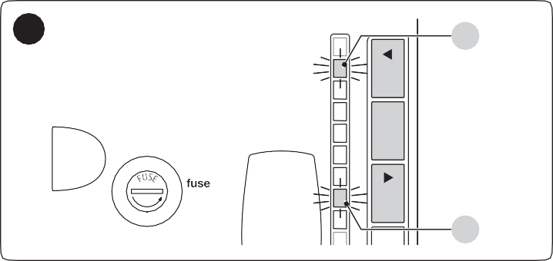
The “Maintenance notice” function can be used to verify the number of manoeuvres completed as a percentage of the set limit.
26
L1
1.6AT
L7
L8 L7 L6
L5 L4 L3
L2 L1
Close
Stop/Set
Open
To do this:
- press and hold the g button until LED “L1” starts flashing
- release the g button when LED “L1” starts flashing
- press the f or h button to shift the flashing LED to “L7”, that is, the “entry LED” for the “Maintenance notice” parameter
- press and hold the g button. With the g
button pressed:
  - wait roughly 3 seconds until the LED representing the current level of the “Maintenance notice” parameter lights up
  - press and immediately release the f and
h buttons
  - the LED corresponding to the selected level will flash
several times; the number of flashes indicates the percentage of manoeuvres completed (in multiples of 10%) with respect to the set limit. For example: with the maintenance notice set to L6, namely 10,000, if the viewing LED flashes 4 times, it means that 40% of the manoeuvres has been reached (i.e. between 4,000 and 4,999 manoeuvres). The LED will not flash unless 10% of the manoeuvres have been completed.
- release the g button.

Manoeuvre counter resetting
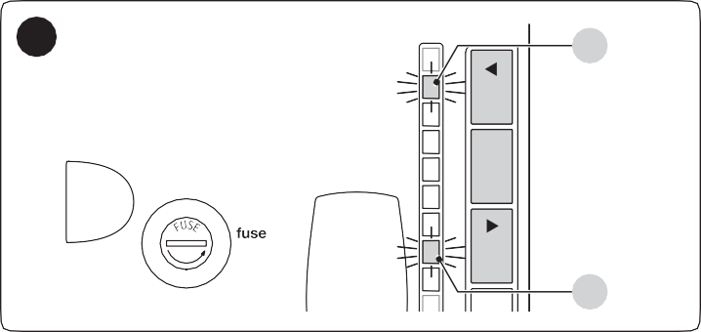
Once maintenance has been performed on the system, the manoeuvre counter must be reset.
27
L1
1.6AT
L7
L8 L7 L6 L5 L4 L3 L2 L1
Stop/Set Open

To do this:
ver
Close
- press and hold the g button until LED “L1” starts flashing
- release the g button when LED “L1” starts flashing
- press the f or h button to shift the flashing LED to “L7”, that is, the “entry LED” for the “Maintenance notice” parameter
- press and hold the g button. With the g
button pressed:
  - wait roughly 3 seconds until the LED representing the current level of the “Maintenance notice” parameter lights up
  - press and hold for at least 5 seconds the f and h buttons then release them. The LED corresponding to the selected level will emit a series of fast flashes to signal that the manoeuvre counter has been reset
- release the g button

ver

8
TROUBLESHOOTING...
(troubleshooting guide)

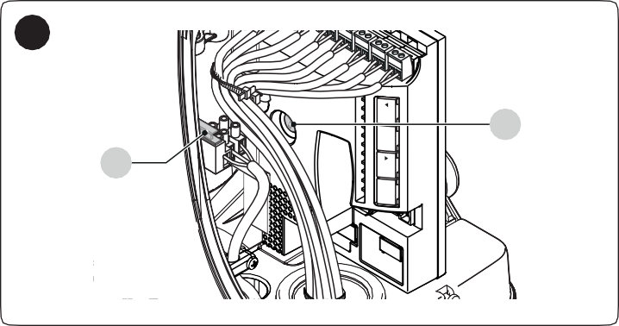
TROUBLESHOOTING
28
F2
F1
L8 L7 L6 L5 L4 L3 L2 L1
Stop/Set Open
The table below contains useful instructions to resolve any malfunctions or errors that may occur during installation or in case of a fault.
Close

Table 9
TROUBLESHOOTING
Problems | Recommended checks
The radio transmitter does not control the gate and the LED on the transmitter does not light up | Check whether the transmitter batteries are exhausted and replace them if necessary.
The radio transmitter does not control the gate but the LED on the transmitter lights up | Check whether the transmitter has been memorised correctly in the radio receiver.
No manoeuvre starts and the “BlueBUS” LED does not flash | Check that the gearmotor is being powered with the mains voltage  Check whether fuses F1 and F2 are blown; if they are, identify the cause of the failure then replace the fuses with others having the same current rating and characteristics.
No manoeuvre starts and the warning light is off | Check that the command is actually received. If the command reaches the Step-by-Step input, the corresponding “SbS” LED must light up; if instead the radio transmitter is used, the “BluBus” LED must emit two quick flashes.
No manoeuvre starts and the warning light flashes a few times | Count the number of flashes and check the corresponding value in “Table 10”.
The manoeuvre starts but is immediately followed by a reverse run | The selected force value may be too low to move the type of gate. Check whether there are any obstacles and, if necessary, select a higher force.
The manoeuvre is completed correctly but the warning light does not work | Make sure that there is voltage on the warning light’s FLASH terminal during the manoeuvre (being intermittent, the voltage value is not significant: roughly 10–30 Vc); if there is voltage, the problem is due to the lamp, which must be replaced with one having the same  characteristics; if there is no voltage, there may have been an overload on the FLASH output. Check that the cable has not short-circuited.
The manoeuvre is completed correctly but the OGI (Open Gate Indicator) does not work | Check the type of function programmed for the OGI output (“Table 7”).  When the indicator light should be lit, check that there is voltage on the OGI terminal (roughly 24 Vc); if there is voltage, the problem is due to the indicator light, which must be replaced with one having the same characteristics; if there is no voltage, there may have been an overload on the OGI output. Check that the cable has not short-circuited.

ANOMALY LOG
The gearmotor allows for displaying any anomalies that occurred in the last 8 manoeuvres, for example, the interruption of a manoeuvre due to the intervention of a photocell or sensitive edge.
To do this:
- press and hold the g button until LED “L1” starts flashing
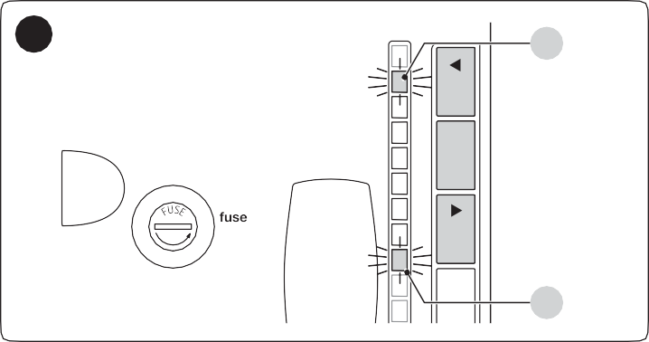
- release the g button when LED “L1” starts flashing
29
L1
1.6AT
L8
L5 L4 L3
L2 L1
Stop/Set
Open
- press the f or h button to shift the flashing LED to “L8”, that is, the “entry LED” for the “List of anomalies” parameter
- press and hold the g button. With the g
button pressed:
  - wait roughly 3 seconds, after which the LEDs corresponding to the manoeuvres that had anomalies will light up. LED L1 indicates the result of the most recent manoeuvre, while LED L8 indicates the result of the eighth manoeuvre. If the LED is lit, it means that anomalies occurred during the manoeuvre; if the LED is off, the manoeuvre terminated without any anomalies
  - press the f or h button to select the desired manoeuvre: the corresponding LED will flash the same number of times as those emitted by the warning light following an anomaly (see “Table 10”)
- release the g button.
Receiver
L8 L7 L6
Close

SIGNALLING THROUGH WARNING LIGHT
During the manoeuvre, the “FLASH” warning light flashes once every second; whenever anomalies occur, shorter flashes are emitted; the flashes are repeated twice with a one-second pause in between.

Table 10
FLASH WARNING LIGHT SIGNALS
Fast flashes | Cause | ACTION
1 flash  1-second pause 1 flash | BlueBus system error | At the start of the manoeuvre, the test to verify the devices connected to the BLUEBUS does not provide the same devices memorised during the learning phase. There may be defective devices: check and replace them if necessary; if changes have been made, the learning procedure must be repeated.
2 flashes  1-second pause 2 flashes | Intervention of a photocell | At the start of the manoeuvre, one or more photocells are blocking the movement; check whether there are any  obstacles. During the manoeuvre, this is normal if an obstacle is present.
3 flashes  1-second pause 3 flashes | Intervention of the “Motor Force” limiter | During the gate’s movement, the motors encountered more resistance; verify the cause and increase the motor force if necessary.
4 flashes  1-second pause 4 flashes | Intervention of the STOP input | At the start of the manoeuvre or during the movement, the STOP input intervened; identify the cause.
5 flashes  1-second pause 5 flashes | Error in the internal parameters of the control unit | Wait at least 30 seconds then try giving a command; if the condition persists, it means that there is a serious malfunction and the electronic board must be replaced.
6 flashes  1-second pause 6 flashes | The maximum number of manoeuvres per hour limit has been exceeded | Wait a few minutes until the manoeuvre limiter drops below the maximum limit.
7 flashes  1-second pause 7 flashes | Error in the internal electric circuits | Disconnect all power circuits for a few seconds then try giving a command again; if the condition persists, it means that there is a serious malfunction and the electronic board must be replaced.
8 flashes  1-second pause 8 flashes | A command that prevents other commands from being executed is already present | Check the type of command that is always present; for example, it could be a command from a timer on the “Open” input.
9 flashes  1-second pause 9 flashes | The automation was stopped by a “Stop automation” command | Unlock the automation mechanism by giving the “Unlock automation” command.

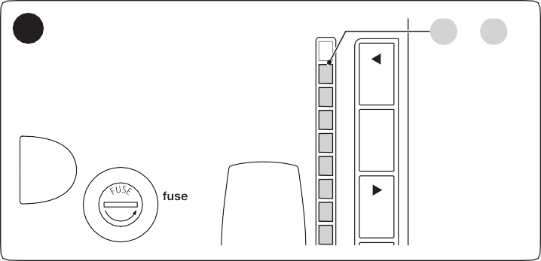
SIGNALS ON THE CONTROL UNIT
30
L1 ... L8
1.6AT
The control unit has a series of LEDs, each of which can emit special signals both during regular operation and when an anomaly occurs.
L8 L7 L6 L5 L4 L3 L2 L1
Stop/Set Open

Table 11
r
Close
TERMINAL LEDS ON THE CONTROL UNIT
Status | Meaning | Possible solution
BlueBus LED
OFF | Anomaly | Check for the presence of power; check that the fuses are not blown; if necessary, identify the cause of the fault then replace them with fuses having the same specifications.
On | Serious anomaly | There is a serious anomaly; try switching off the control unit for a few seconds; if the condition persists, it means that there is a fault and the electronic circuit board must be replaced.
1 flash per second | Everything normal | Normal control unit operation.
2 fast flashes | The status of the inputs has changed | This is normal when there is a change in the status of the STOP or OPEN input, when the photocells activate or when the radio transmitter is used.
A series of flashes separated by a 1-second pause | Various | Refer to that shown in “Table 10”.

TERMINAL LEDS ON THE CONTROL UNIT
Status | Meaning | Possible solution
STOP LED
OFF | Intervention of the STOP input | Check the devices connected to the STOP input.
On | Everything normal | STOP input active.
Sbs LED
OFF | Everything normal | Sbs input not active.
On | Intervention of the Sbs input | This is normal if the device connected to the Sbs input is actually active.
OPEN LED
OFF | Everything normal | OPEN input not active.
On | Intervention of the OPEN input | This is normal if the device connected to the OPEN input is actually active
CLOSE LED
OFF | Everything normal | CLOSE input not active.
On | Intervention of the CLOSE input | This is normal if the device connected to the CLOSE input is actually active.
AUX_IN LED
OFF | Opening of the AUX_IN input contact | Check the devices connected to the AUX_IN input
On | Everything normal | AUX_IN input active

Table 12
LEDS ON THE CONTROL UNIT BUTTONS
LED 1 | Description
OFF | During normal operation, this indicates that “Automatic Closing” is disabled.
On | During normal operation, this indicates that “Automatic Closing” is active.
Flashes | Function programming in progress.  If it flashes together with “L2”, it means that the device learning phase must be carried out (refer to the “  Device learning” paragraph).
LED 2 | Description
OFF | During normal operation, it signals that the “Close after photo” mode is not active.
On | During normal operation, it signals that the “Close after photo” mode is active.
Flashes | Function programming in progress.  If it flashes together with “L1”, it means that the device learning phase must be carried out (see the “  Device learning” paragraph)
LED 3 | Description
OFF | During normal operation, this indicates that “Always Close” is not active.
On | During normal operation, it signals that “Always close” is active.
Flashes | Function programming in progress.  If it flashes together with L4, it means that the leaf length learning phase must be carried out (refer to the “  Leaf length learning” paragraph).
LED 4 | Description
OFF | During normal operation, it signals that the “Stand-by” mode is not active.
On | During normal operation, it signals that the “Stand-by” mode is active.
Flashes | Function programming in progress.  If it flashes together with L3, it means that the leaf length learning phase must be carried out (refer to the “  Leaf length learning” paragraph).
LED 5 | Description
OFF | During normal operation, it indicates that the “Peak” mode is not active.
On | During normal operation, it signals that the “Peak” mode is active.
Flashes | Function programming in progress.
LED 6 | Description
OFF | During normal operation, it signals that the “Pre-flashing” mode is not active.
On | During normal operation, it signals that the “Pre-flashing” mode is active.
Flashes | Function programming in progress.
LED 7 | Description
OFF | During normal operation, it signals that the “CLOSE” input triggers a closing manoeuvre.
On | During normal operation, it signals that the “CLOSE” input triggers a partial opening manoeuvre.
Flashes | Function programming in progress.
LED 8 | Description
OFF | During normal operation, it signals that RUN1500 is configured as master.
On | During normal operation, it signals that RUN1500 is configured as slave.
Flashes | Function programming in progress.

9
FURTHER INFORMATION
(Accessories)

ADDING OR REMOVING DEVICES
Once the automation has been assembled, it is possible to add or remove devices at any time. In particular, various types of devices can be connected to the “BlueBUS” and “STOP” inputs, as described in the following paragraphs.

m After having added or removed devices, these must be learned as described in the “Learning of other devices” paragraph.

BlueBUS
BlueBUS is a technique that allows for connecting compatible devices with only two wires which carry the electrical power and the communication signals. All devices are connected in parallel on the same 2 BlueBUS wires and without having to observe the polarities; each device is recognised because it is assigned a univocal address during the installation phase.
The following devices can be connected to the BlueBUS: photocells, safety devices, control buttons, signalling lights, etc. The control unit recognises all the connected devices individually through an appropriate learning phase, and can detect all possible anomalies with absolute precision.
For this reason, whenever a device is connected to or removed from BlueBUS, the learning phase must be carried out on the control unit, as described in the “Learning of other devices” paragraph.

STOP input
STOP is the input that causes immediate stoppage of the manoeuvre followed by its brief reversal. Devices with output featuring normally open “NO” and normally closed “NC” contacts, as well as devices with 8.2 kΩ fixed resistor output, such as sensitive edges, can be connected to this input.
As with the BlueBUS, the control unit recognises the type of device connected to the STOP input during the learning phase (see the “Learning of other devices” paragraph); subsequently the control unit gives a STOP command when it detects a variation with respect to the recognised status.
Multiple devices, even of different types, can be connected to the STOP input if suitable arrangements are made:
- Any number of NO devices can be connected to each other in parallel.
- Any number of NC devices can be connected to each other in series.
- Two devices with 8.2 kΩ fixed resistor output can be connected in parallel; if there are more than 2 devices then they must all be connected in cascade, with a single 8.2 kΩ terminating resistor.
- It is possible to combine two NO and NC contacts by placing them in parallel, while also mounting a 8.2 kΩ resistor in series with the NC contact (this also allows for combining 3 devices: NA, NC and 8.2 kΩ).

a If the STOP input is used to connect devices with safety functions, only those devices with 8.2 kΩ fixed resistor guarantee Category 3 safety against
faults in accordance with the EN 13849-1 standard.

Photocells
To allow the control unit to recognise the devices connected through the “BlueBUS” system, these devices must be addressed.
This operation can be carried out by correctly positioning the electrical jumper present in each device (also refer to the instruction manual of each device). Shown below is an addressing diagram for photocells, based on their type.
31
FOTO II
FOTO 1 II
FOTO 1
FOTO

Table 13
FOTO 2
FOTO 2 II
FOTO 3

PHOTOCELL ADDRESSES
Photocell | Position of the jumpers
FOTO (PHOTO)  External photocell h = 50 activated during the closing phase (stops and reverses the gate’s movement) | 
FOTO II (PHOTO II)  External photocell h = 100 activated during the closing phase (stops and reverses the gate’s movement) | 
FOTO 1 (PHOTO 1)  Internal photocell h = 50 activated during the closing phase (stops and reverses the gate’s movement) | 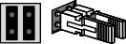
FOTO 1 II (PHOTO 1 II)  Internal photocell h = 100 activated during the closing phase (stops and reverses the gate’s movement) | 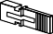
FOTO 2 (PHOTO 2)  External photocell activated during the opening phase | 
FOTO 2 II (PHOTO 2 II)  Internal photocell activated during the opening phase | 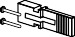
FOTO 3 (PHOTO 3)  Single photocell covering the entire automation | 

a In order to jointly install PHOTO 3 and PHOTO II, the position of the elements making up the photocell (TX - RX) must comply with the warning indicated in
the instruction manual of the photocells.

m At the end of the installation procedure, or after photocells or other devices have been removed, it is necessary to complete the learning procedure
(see the “Device learning” paragraph).

FT210B photosensor
The FT210B photosensor combines in a single device a force limiting system (type C, in accordance with the EN12453 standard) and a presence sensor that detects obstacles on the line of sight between the TX transmitter and RX receiver (type D, in accordance with the EN12453 standard). In the FT210B photosensor, the signals regarding the status of the sensitive edge are sent through the photocell range, integrating the 2 systems in a single device. The transmitting element located on the moving leaf is battery-powered, which eliminates visually unpleasant connection systems; special circuits reduce battery consumption, ensuring up to 15 years’ life (see estimation details in the product’s instructions).
A single FT210B device combined with a sensitive edge (TCB65, for example) allows for attaining the level of safety of the “primary edge” required by the EN12453 standard for all “types of use” and “types of activation”.
The FT210B photosensor combined with the “resistive” sensitive edges (8.2 kΩ) is safe against faults (category 3 pursuant to the EN 13849-1 standard). It is equipped with a special anti- collision circuit to prevent interference with other detectors, even not synchronised, and allows for adding other photocells; for example, in case of transit of heavy vehicles, where a second photocell is normally positioned 1 m above the ground.

l Consult the FT210B instruction manual for further information on the connection and addressing methods.

Gearmotor in SLAVE mode
The motor can function in SLAVE mode by suitably programming and connecting it; this operating mode is used to automate two opposite leaves that must move in a synchronised manner. In this mode, a motor functions as MASTER, in other words, it commands the manoeuvres, while the second motor functions as SLAVE, executing the commands sent by the MASTER (all the motors are MASTER by default).
The connection between MASTER and SLAVE is made via BlueBUS.

m In this case, the polarity of the connections between the two motors must be observed, as illustrated in “Figure 32” (the other devices will continue not
having polarity).

l It is not important which motor functions as MASTER or SLAVE; the choice must take into account the ease of the connections and the fact that the “Step-
by-Step” command of the SLAVE device allows the full opening of the SLAVE leaf only.

Perform the following operations to install two motors in MASTER and SLAVE mode:
- install the two motors
- connect the two motors as shown in “Figure 32”

32
TX RX

1 2 1 2

FLASH
OGI 24V 4W
STOP

NO NC 8K2
SBS

NO
FLASH
OGI 24V 4W

NO NC 8K2

NC NO NO NO

AUX IN CLOSE OPEN
OGI
Sbs
Flash
OGI
Bluebus
Stop
Sbs
Open
Close
L8 L7 L6 L5 L4 L3 L2 L1
Aux In
Close Stop/Set Open

Bluebus MASTER
Flash
Bluebus
Stop
Open
Close
L8 L7 L6 L5 L4 L3 L2 L1
Aux In
Stop/Set
Open
Bluebus SLAVE

1.6AT 1.6AT

1 2 1 2
Receiver
Aerial
Close
Bluebus
Bluebus
Receiver
Aerial

IBT4N
MASTER Board

IBT4N
SLAVE Board

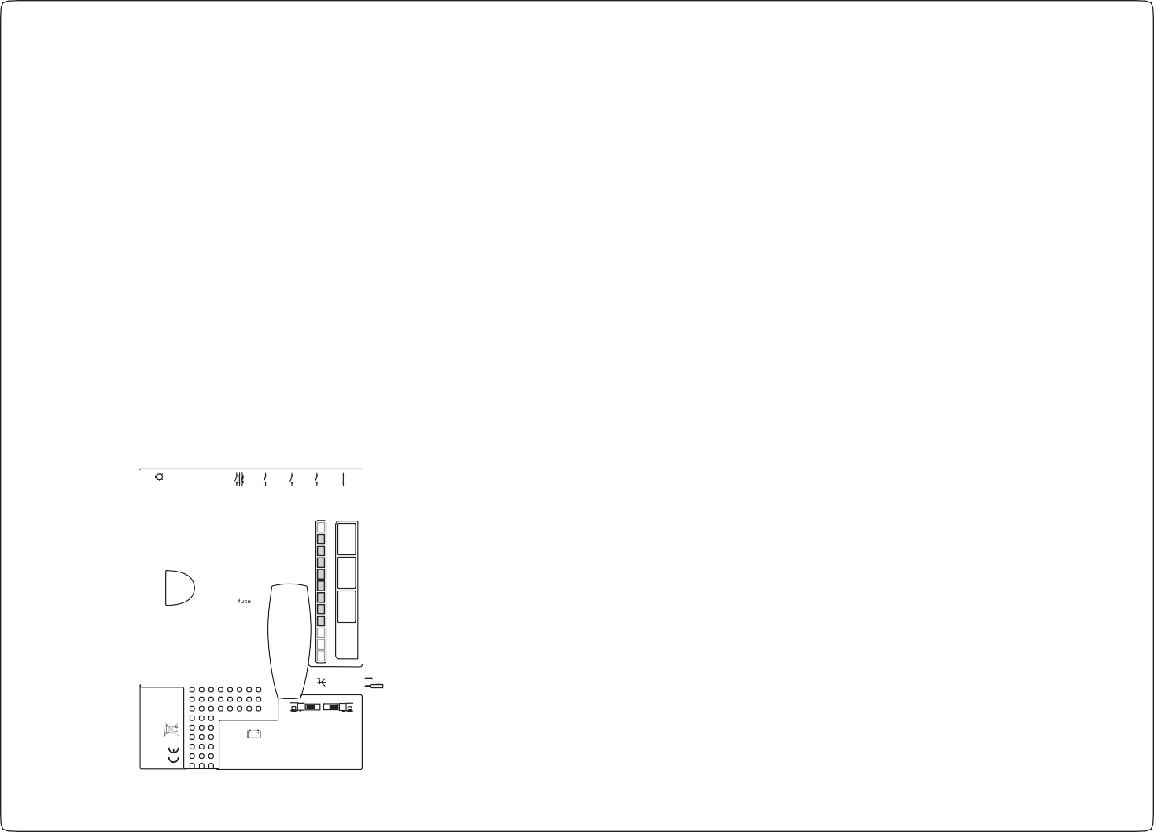


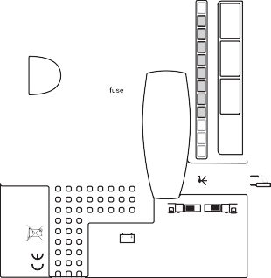


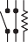


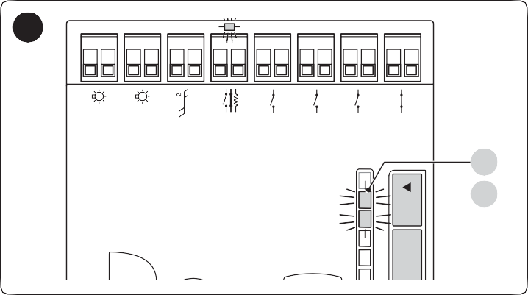
- select the opening direction of the two motors, as shown in the figure (also refer to the “Choosing the direction” paragraph)
34
L1
L2
Flash
OGI
Bluebus
Stop
Sbs
Open
Close
Aux In
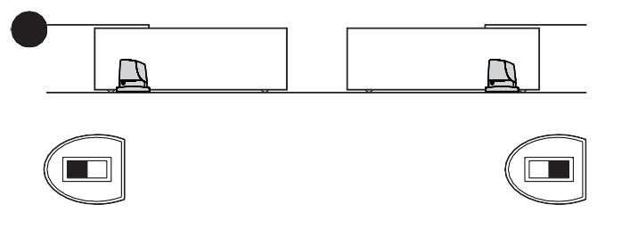
33

- power the two motors
Stop/Set Open
- in the SLAVE motor, programme the “SLAVE mode” function (see “Table 6”)
- perform the procedure for acquiring devices on the SLAVE motor (see the “Device learning” paragraph)
- perform the procedure for acquiring devices on the MASTER motor (see the “Device learning” paragraph)
- perform the procedure for acquiring the length of the leaves on the MASTER motor (see the “Leaf length learning” paragraph).
In connecting the two motors in SLAVE-MASTER mode, verify that:
  - all devices must be connected to the MASTER motor (as shown in “Figure 32”), including the radio receiver
  - when using back-up batteries, each motor must have its own battery
Once a motor has been configured as SLAVE, it nonetheless maintains some functions (listed below) separate from the MASTER motor.

Level 1 functions (ON-OFF functions)
  - Stand-by
  - Peak
  - Slave mode

Level 2 functions (adjustable parameters)
  - OGI output
  - Motor force
  - Error log
On the SLAVE motor it is possible to connect:
  - an own warning light (Flash)
  - an own Open Gate Indicator (OGI)
  - an own sensitive edge (Stop)
  - an own command device (Sbs) that controls the full opening of the Slave leaf only.
  - In the Slave, the Open, Close and Aux_In inputs are not used.

m In the SLAVE, the “Open”, “Close” and “Aux_In” inputs are not used.

Learning of other devices
Normally the learning of devices connected to “BlueBUS” and the “STOP” input takes place during the installation stage; however, if new devices are added or old ones removed, the learning process can be redone.

To do this:
L5 L4 L3 L2 L1
- simultaneously press and hold the f and
g buttons
- release the buttons when LEDs “L1” and “L2” start flashing
rapidly (after roughly 3 seconds)
- wait a few seconds until the control unit has completed the device learning phase
- at the end of this phase, the “Stop” LED must be lit, LEDs “L1” and “L2” must switch off, while LEDs “L1… L8” will switch on depending on the status of the ON-OFF functions they represent.

m After having added or removed devices, the automation test must be carried out again as specified in the “Testing” paragraph.

Connecting an SM-type radio receiver
The control unit has a slot for mounting radio receivers with SM connector (optional accessories) belonging to the SMXI, OXI, etc. families, which can be used to remotely control the control unit through transmitters that intervene on the unit’s inputs.
To install a receiver (“Figure 35”):
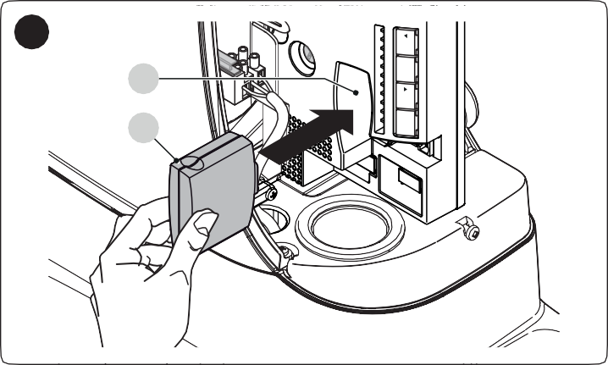
1. insert the receiver (A) in the appropriate slot (B) on the control unit’s electronic board.
35
B
A
L8 L7 L6 L5 L4 L3 L2 L1
Close Stop/Set Open

The association between the radio receiver output and the command executed by the motor is shown in “Table 14”:

Table 14
SMXI / SMXIS OR OXI / OXIFM / OXIT / OXITFM IN MODE 1 OR MODE 2
Receiver output | Command
Output No. 1 | “Step-by-Step”
Output No. 2 | “Partial opening”
Output No. 3 | “Open”
Output No. 4 | “Close”

If the OXI radio receiver used in “EXTENDED MODE” is installed, it may send the commands shown in “Table 15“.

Table 15

OXI / OXIFM /OXIT / OXITFM IN MODE 2 EXTENDED
No. | Command | Description
1 | Step-by-Step | “SbS” (Step-by-Step) command
2 | Partial opening 1 | “Partial opening 1” command
3 | Open | “Open” command
4 | Close | “Close” command
5 | Stop | Stops the manoeuvre
6 | Condominium Step-by-Step | Command in condominium mode
7 | High priority Step- by-Step | Commands also with the automation locked or the commands enabled
8 | Partial open 2 | Partial opening (the M2 gate leaf opens to 1/2 the full length)
9 | Partial open 3 | Partial open (the two gate leaves open to 1/2 the full length)
10 | Opens and locks the automation | Triggers an opening manoeuvre and, once this terminates, locks the automation; the control unit will not accept any command other than “High priority Step-by-Step” and automation “Unlock”, or (only from Oview) the following commands: “Unlock and close” and “Unlock and open”
11 | Closes and locks the automation | Triggers a closing manoeuvre and, once this terminates, locks the automation; the control unit will not accept any command other than “High priority Step-by-Step” and automation “Unlock”, or (only from Oview) the following commands: “Unlock and close” and “Unlock and open”
12 | Lock automation | Triggers the stoppage of the manoeuvre and locks the automation; the control unit will not accept any command other than “High priority Step-by-Step” and automation “Unlock”, or (only from Oview) the following commands: “Unlock and close” and “Unlock and open”
13 | Release automation | Triggers unlocking of the automation and restores normal operation
14 | On Timer Courtesy light | The courtesy light output switches on with timer-based switching off
15 | On-Off Courtesy light | The courtesy light output switches on and off in Step-by-step mode

l For further information, consult the specific manual of the receiver.

Connecting and installing the back-up battery

f The electrical connection of the battery to the control unit must be made only after completing all the installation and programming stages, as the
battery is an emergency power supply.
To install and connect the battery:
- remove the plastic protection (A) with the aid of a screwdriver
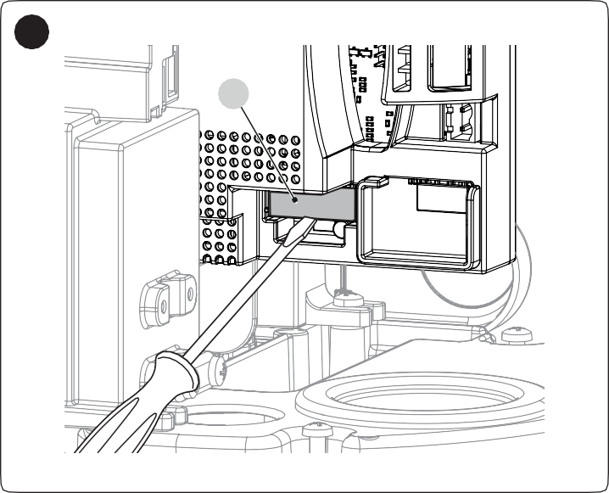
36
A
- slide the battery (B) into its housing
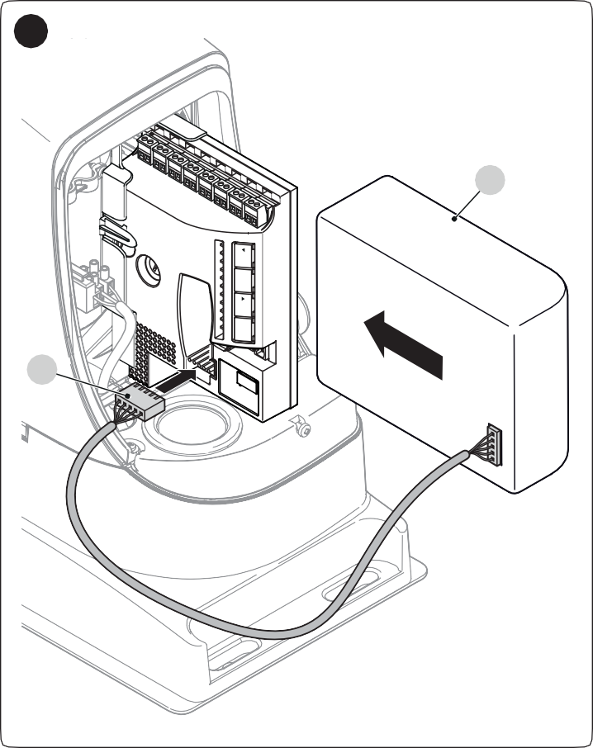
- insert the relative connector (C) on the control unit.
37
B
C

L8 L7 L6 L5 L4 L3 L2 L1
Close Stop/Set Open

Connecting the Oview programmer
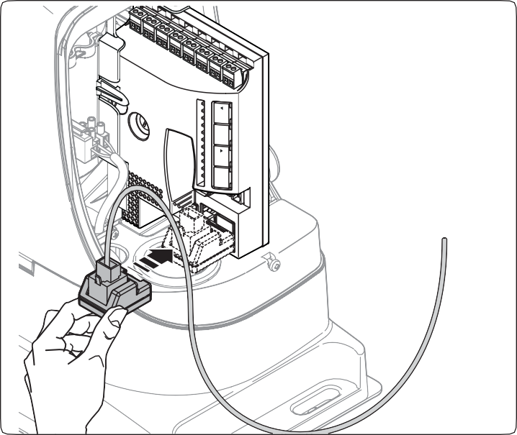



The control unit has a BusT4 connector to which the “Oview” programmer can be connected, through the IBT4N interface. The programmer allows for fully and rapidly managing the installation, maintenance and diagnosis of the entire automation. To access the connector, proceed as shown in the figure and connect the connector to its relevant slot.
38
L8 L7 L6 L5 L4 L3 L2 L1
Close
Stop/Set Open
The Oview may be connected to multiple control units simultaneously (up to 5 with no particular precautions, up to 60 with the warnings stated) and may be left connected to the control unit during normal operation of the automation. In this case, it can be used to directly send commands to the control unit through the specific “user” menu.
It is also possible to update the firmware. If the control unit has a radio receiver belonging to the OXI family, the “Oview” can be used to access the transmitter parameters memorised in the receiver.
For more detailed information, consult the respective instruction manual and the “Opera system book” manual.

Connecting the Solemyo solar energy system

f When the automation is powered by the “Solemyo” system, IT MUST NOT BE POWERED by the electricity grid at the same time.
To connect the “Solemyo” system:
- remove the plastic protection (A) with the aid of a screwdriver
- insert the relative connector (B) on the control unit.

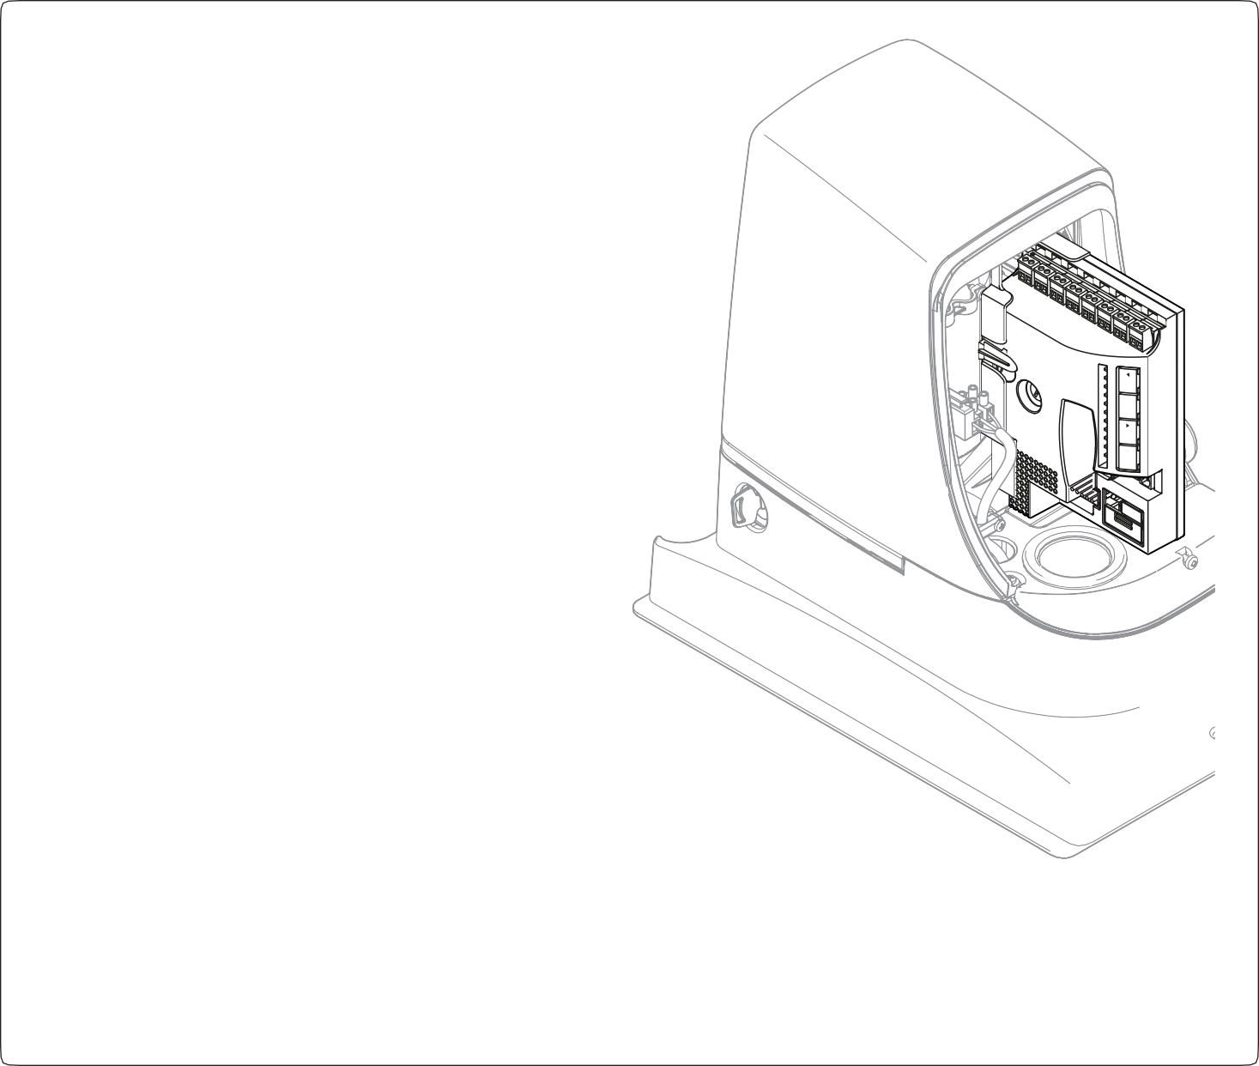


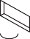


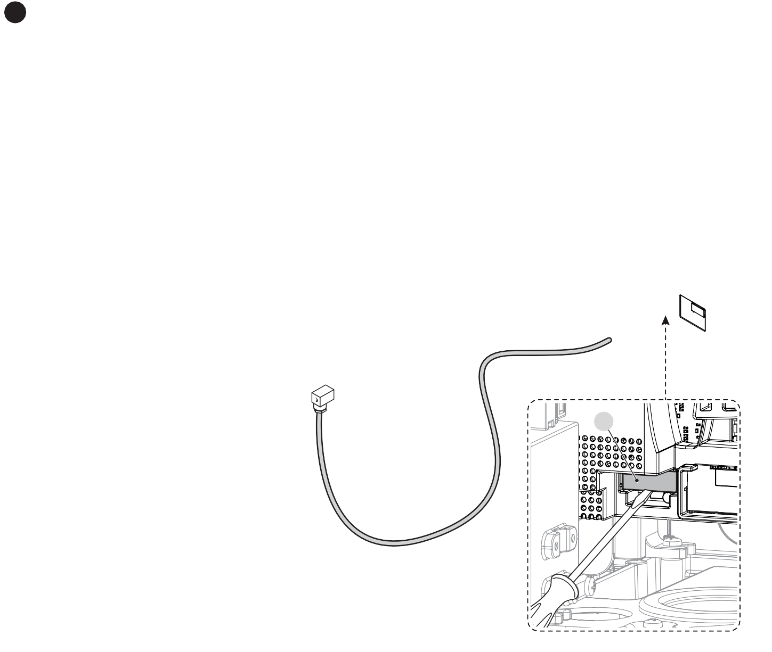
39

B
L8 L7 L6 L5 L4 L3 L2 L1
Close Stop/Set Open

A

10
PRODUCT MAINTENANCE
11
PRODUCT DISPOSAL

The automation must be subjected to regular maintenance to keep its safety level constant and guarantee long-lasting operation; to this aim, RUN has a manoeuvre counter and maintenance warning system; refer to the ““Maintenance notice” function” paragraph.

a Maintenance must be carried out strictly in compliance with the safety provisions provided in this manual and in accordance with the laws and
regulations in force.
To carry out maintenance on the gearmotor:
- Schedule maintenance interventions within maximum 6 months or after maximum 20.000 manoeuvres from the previous maintenance intervention
- disconnect all power supplies, including any back-up batteries
- check for any deterioration in the materials making up the automation, with special emphasis on erosion or oxidation of the structural parts; replace any parts that are not to standard
- check the state of wear of moving parts: pinion, rack and all gate leaf components; replace any worn parts
- connect the power supplies again and run all the tests and checks described in the “Testing” paragraph.

l This product is an integral part of the operator and must therefore be disposed of with it.
As with the installation, only qualified personnel must dismantle the product at the end of its life.
This product is composed of different types of materials. Some of these materials can be recycled; others must be disposed of. Please enquire about the recycling or disposal systems in place in your local area for this type of product.
a WARNING
Some parts of the product may contain polluting or dangerous substances. If not disposed of correctly, these substances may have a damaging effect on the environment and human health.

l As indicated by the symbol shown here, this product must not been disposed of with household
waste. Separate the waste for disposal and recycling, following the methods stipulated by local regulations, or return the product to the seller when purchasing a new product.

a WARNING
Local regulations may impose heavy penalties if this product is not disposed of in compliance with the law.

12
TECHNICAL SPECIFICATIONS

l All technical specifications stated in this section refer to an ambient temperature of 20°C (± 5°C). Nice S.p.A. reserves the right to apply modifications to the product at any time when deemed necessary, without altering its functions and intended use.

Table 16
TECHNICAL SPECIFICATIONS
Description | Technical specification
Pinion | Pinion Z: 18  Module: 4  Pitch: 12.6 mm  Primitive diameter: 72 mm
Maximum inrush torque  (corresponds to the ability to generate the necessary force to move the leaf) | 35 Nm  (1000 N)
Nominal torque  (corresponds to the ability to generate the necessary force to move the leaf) | 20 Nm  (560 N)
Nominal torque speed | 0.18 m/s
No-load speed  (the control unit allows for programming 6 speeds approximately equal to: 100, 85, 70, 55, 45, 30%) | 0.25 m/s
Maximum frequency of operation in cycles/hour (for a standard 4-metre gate) | 60  The control unit limits the cycles to the maximum value specified in Table 1 and Table 2
Maximum continuous operating time | 10 minutes
Application limits | The Run devices are generally able to automate gates with weight and length within the limits specified in Table 1 and Table 2
Maximum peak power input (corresponding to amperes) | 400 W
Dimensions and weight | 400 x 255 h 390; 19 kg

13
CONFORMITY
EU Declaration of Conformity
and declaration of incorporation of “partly completed machinery”
Note - The contents of this declaration correspond to declarations in the official document deposited at the registered offices of Nice S.p.a. and in particular to the last revision available before printing this manual. The text herein has been re-edited for editorial purposes. A copy of the original declaration can be requested from Nice S.p.a. (TV) I.
Number: 238/RUN Rev: 13 Language: EN
Manufacturer’s Name: Nice s.p.a.
Address: Via Pezza Alta 13, Z.I. Rustignè, 31046 Oderzo (TV) Italy
Authorized Person to constitute
technical documentation: Nice s.p.a.
Type of product: Electromechanical gear motor with incorporated control unit
Model/Type: RUN1500, RUN1500P, RUN1500/V1
Accessories: Refer to the catalog
The undersigned Roberto Griffa, in the role of Chief Executive Officer, declares under his sole responsibility that the product described above complies with the provisions
laid down in the following directives:
- Directive 2014/30/EU (EMC), according to the following harmonized standards: EN 61000-6-2:2005, EN 61000-6-3:2007+A1:2011
The product also complies with the following directives according to the requirements envisaged for “partly completed machinery” (Annex II, part 1, section B):
- Directive 2006/42/EC of the EUROPEAN PARLIAMENT AND COUNCIL of 17 May 2006 related to machinery and amending the Directive 95/16/EC (recast).
It is hereby stated that the relevant technical documentation has been compiled in accordance with annex VII B of Directive 2006/42/EC and that the following essential
requirements have been fulfilled: 1.1.1 - 1.1.2 - 1.1.3 - 1.2.1 - 1.2.6 - 1.5.1 - 1.5.2 - 1.5.5 - 1.5.6 - 1.5.7- 1.5.8 - 1.5.10 - 1.5.11
The manufacturer undertakes to transmit to the national authorities, in response to a reasoned request, the relevant information on the “ partly completed machinery “, while maintaining full rights to the related intellectual property.
Should the “ partly completed machinery” be put into service in a European country with an official language other than that used in this declaration, the importer is obliged
to arrange for the relative translation to accompany this declaration.
The “partly completed machinery” must not be used until the final machine in which it is incorporated is in turn declared as compliant, if applicable, with the provisions of
directive 2006/42/EC.

The product also complies with the following standards:
EN 60335-1:2012+A11:2014, EN 62233:2008, EN 60335-2-103:2015

Oderzo, 16/05/2018
Ing. Roberto Griffa
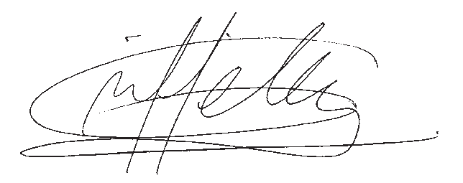
(Chief Executive Officer)

INSTRUCTIONS AND WARNINGS FOR THE USER

Before using the automation for the first time, ask the installer to explain the origin of any residual risks and take a few minutes to read this instruction manual and warnings for the user given to you by the installer. Store the manual for future reference and hand it to the new owner when transferring the automation. a WARNING!
✀
✀
Your automation is a machine that faithfully executes commands imparted by the user. Negligence and improper use may lead to dangerous situations:
- do not manoeuvre the gate if there are people, animals or objects within its range of operation
- it is strictly forbidden to touch parts of the automation while the gate or door is moving
- the photocells are not a safety device but only an auxiliary aid to safety. They are built using highly reliable technology but, in extreme conditions, may malfunction or even become defective. In certain cases, the defect may not be clearly evident. For these reasons, it is important to follow all the instructions given in this manual when using the automation
- periodically check that the photocells work properly.

a IT IS STRICTLY FORBIDDEN to transit through the gate while it is closing! It is only possible to transit through the gate when it is fully open and the leaves
are at a standstill.
a CHILDREN
An automation system guarantees a high degree of safety. With its detection systems, it can control and guarantee the gate’s movement in the presence of people or objects. It is nonetheless advisable to forbid children from playing near the automation and not to leave remote controls near them to prevent any unwanted activation of the system. The automation is not a toy!
The product is not intended for use by persons, including children, with limited physical, sensory or mental capacities, or who lack experience or knowledge, unless supervised or trained in the use of the product by a person responsible for their safety.
Anomalies: if the automation shows any signs of anomalous behaviour, disconnect the power supply to the system and manually unlock the motor (see instructions at the end of the chapter) to manoeuvre the gate manually. Do not attempt any repairs personally but contact your trusted installer.

l Do not modify the system or the programming and adjustment parameters of the control unit: your installer is exclusively responsible for these
operations.
Failure or lack of power supply: while waiting for the installer to intervene or the electricity to be restored, if the system is not equipped with back-up batteries, the automation can nonetheless be used by manually unlocking the motor (consult the instructions at the end of the chapter) and moving the gate leaf manually.
Safety devices out of order: the automation can also be used when one or more safety devices are defective or out of order. The gate can be operated in the “hold-to-run” mode in the following way:
- send a command to operate the gate using a transmitter or key selector, etc. If everything works normally, the gate will move regularly, otherwise the warning light will flash a few times and the manoeuvre will not start (the number of flashes depends on the reason for which the manoeuvre cannot start)
- in this case, within 3 seconds press the control again and hold it down
- after roughly 2 seconds, the gate will complete the requested manoeuvre in “Hold-to-run” mode, in other words, it will continue to move so long as the control is held down.

m If the safety devices are out of order, have the system repaired as soon as possible by a qualified technician.
The test, periodic maintenance and any repairs must be documented by the person carrying out the work and the documents must be stored by the owner of the automation. The only interventions the user may carry out periodically include cleaning of the photocell glass components (use a soft and slightly damp cloth) and removing any leaves or stones that may obstruct the automation.

m Before carrying out any maintenance operations, the user of the automation must manually unlock the motor to prevent anyone from accidentally
triggering the gate’s movement (consult the instructions at the end of the chapter).
Maintenance: in order to ensure constant levels of safety and the longest useful life for the automation, routine maintenance must be carried out (at least every 6 months).

l Only qualified personnel is authorised to carry out checks, maintenance operations and repairs.
Disposal: at the end of its useful life, the automation must be dismantled by qualified personnel and the materials must be recycled or disposed of in compliance with the local regulations in force.
Replacing the remote control battery: if your remote control appears to be working poorly after some time, or stops working altogether, it may simply depend on flat batteries (depending on how much the device is used, the batteries may last from several months to over a year). You will notice this by the fact that the indicator light signalling the transmission fails to light up, is weak or lights up only for a short time. Before contacting the installer, try replacing the battery with that of another transmitter that works properly: if the anomaly is resolved, simply replace the flat battery with one of the same type.

Unlocking and manual movement
✀
✀

a The gate can only be unlocked once the leaf has come to a standstill.
- insert the key (A) and turn it clockwise by 90°
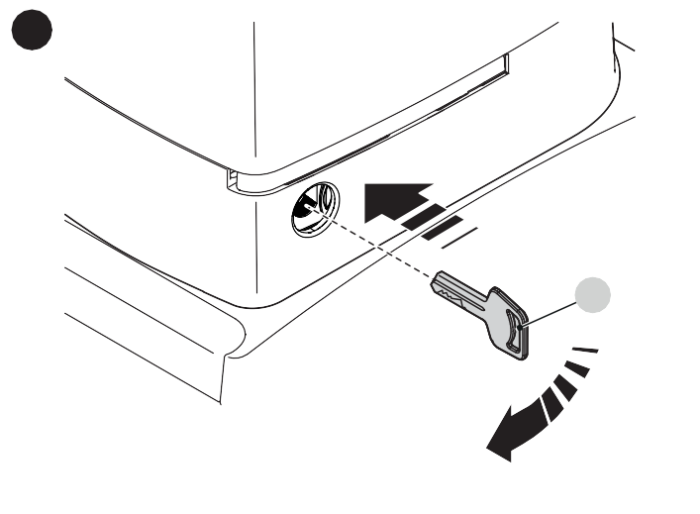
40

A
- move the gate leaf manually.
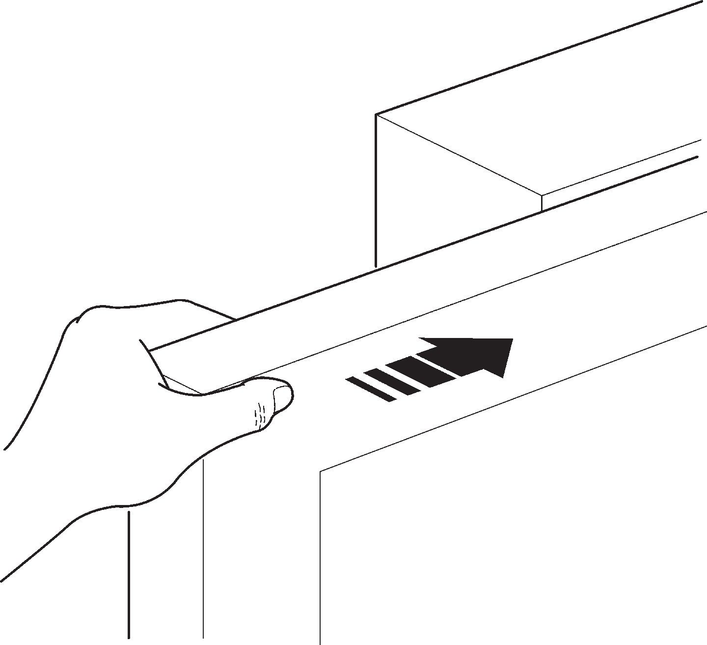
41

NOTES



Nice SpA
IDV0659A01EN_15-02-2019
Via Callalta, 1
31046 Oderzo TV Italy info@niceforyou.com

www.niceforyou.com

